GENERATED · Do not edit this file, edit the source .docx in each subfolder and rerun build_final_manual.py

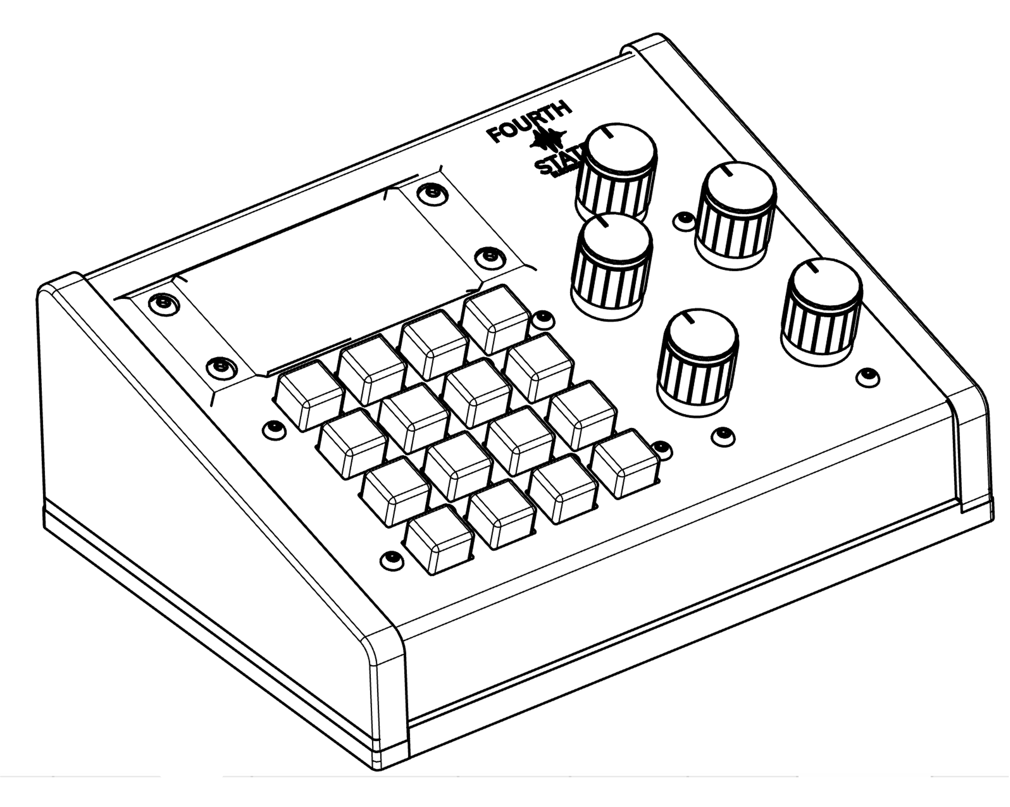
FSE 1
User Manual
Fourth State Electronics
Firmware v1.0
fourthstateelectronics.com

Contents

1 Welcome

The FSE 1 is a compact live-performance MIDI controller with three independent output ports, five assignable knobs, a 16-button pad, a color touchscreen, and an SD card for saving preset banks.
It is designed to sit on top of a synth, keyboard, or modular rack and give you one-hand control over patch changes, split zones, tempo and midi signal processing including velocity shaping, alternate tuning arpeggiation, midi filtering, chord generation, and latching; without the need for a computer.
Nothing on this device requires an app or a driver. Plug in power, connect and configure MIDI, play.

2 What's in the Box

- FSE 1 unit
- Quick-start card

3 Hardware Overview

Front Panel
1. Knobs K1–K5, five potentiometers. Each knob is assignable as a CC on a per-preset basis (which CC it sends, which port, its startup value). In edit and configuration screens, Knob 1 is used to change the value of the currently-selected field.
2. 4 × 4 pad, sixteen illuminated buttons. On the Live screen they are your presets (1–16); in edit and configuration screens they can be used to step values. In the clock screen they are also used to visualize and to tap the tempo.
3. TFT display, 320 × 172 IPS with capacitive touch. Shows the current preset in Live mode; editing happens here.

Rear Panel
1. MIDI OUT A / B / C, three independent 5-pin DIN MIDI outputs.
2. MIDI IN, 5-pin DIN MIDI input, used for external clock sync and for the Program editor's note-learn feature.
3. USB-C 5 V power.
4. Power on switch.

Side Panel
- MicroUSB, firmware updates, optional bank programming, backups and restores.

4 Quick Start

1. Plug in power. Connect any USB-C cable and 5 V USB power source (phone charger, powered hub, laptop USB port) to the POWER jack on the back.
2. Turn the unit on. Flip the rocker switch on the back to ON. The FSE splash logo appears for a moment, then the Live screen loads showing Preset 1.
3. Connect your master keyboard. Plug a 5-pin MIDI cable from your keyboard's MIDI OUT into the MIDI IN jack on the side of the FSE.
4. Connect your destination synths. Plug MIDI cables from MIDI OUT A / B / C on the back into the MIDI IN of each synth or effect you want to control.
Note. If MIDI from the FSE 1 is being routed back into your master keyboard's MIDI IN (so its onboard sounds get processed by the FSE 1), turn Local Control OFF on the master keyboard to prevent doubled notes.
5. Set MIDI channels. On the Live screen, tap SYSTEM (bottom-left). Set the base MIDI channel for A, B, and C to match your synths (typically 1, 2, 3).
6. Play through Preset 1 to verify. Preset 1 sends every note through Port A. Knobs K1–K5 send CC 7 (volume) by default.
7. Switch presets. Tap any of the 16 pad buttons to load that preset.
8. Edit on-device. From Live, tap PRESET (center-bottom) to open the editor for the current pad, or KNOBS (right-bottom) for knob assignments. Edit optional features from the Features tab in the System screen.
You're up and playing. Read on for the full walkthrough.
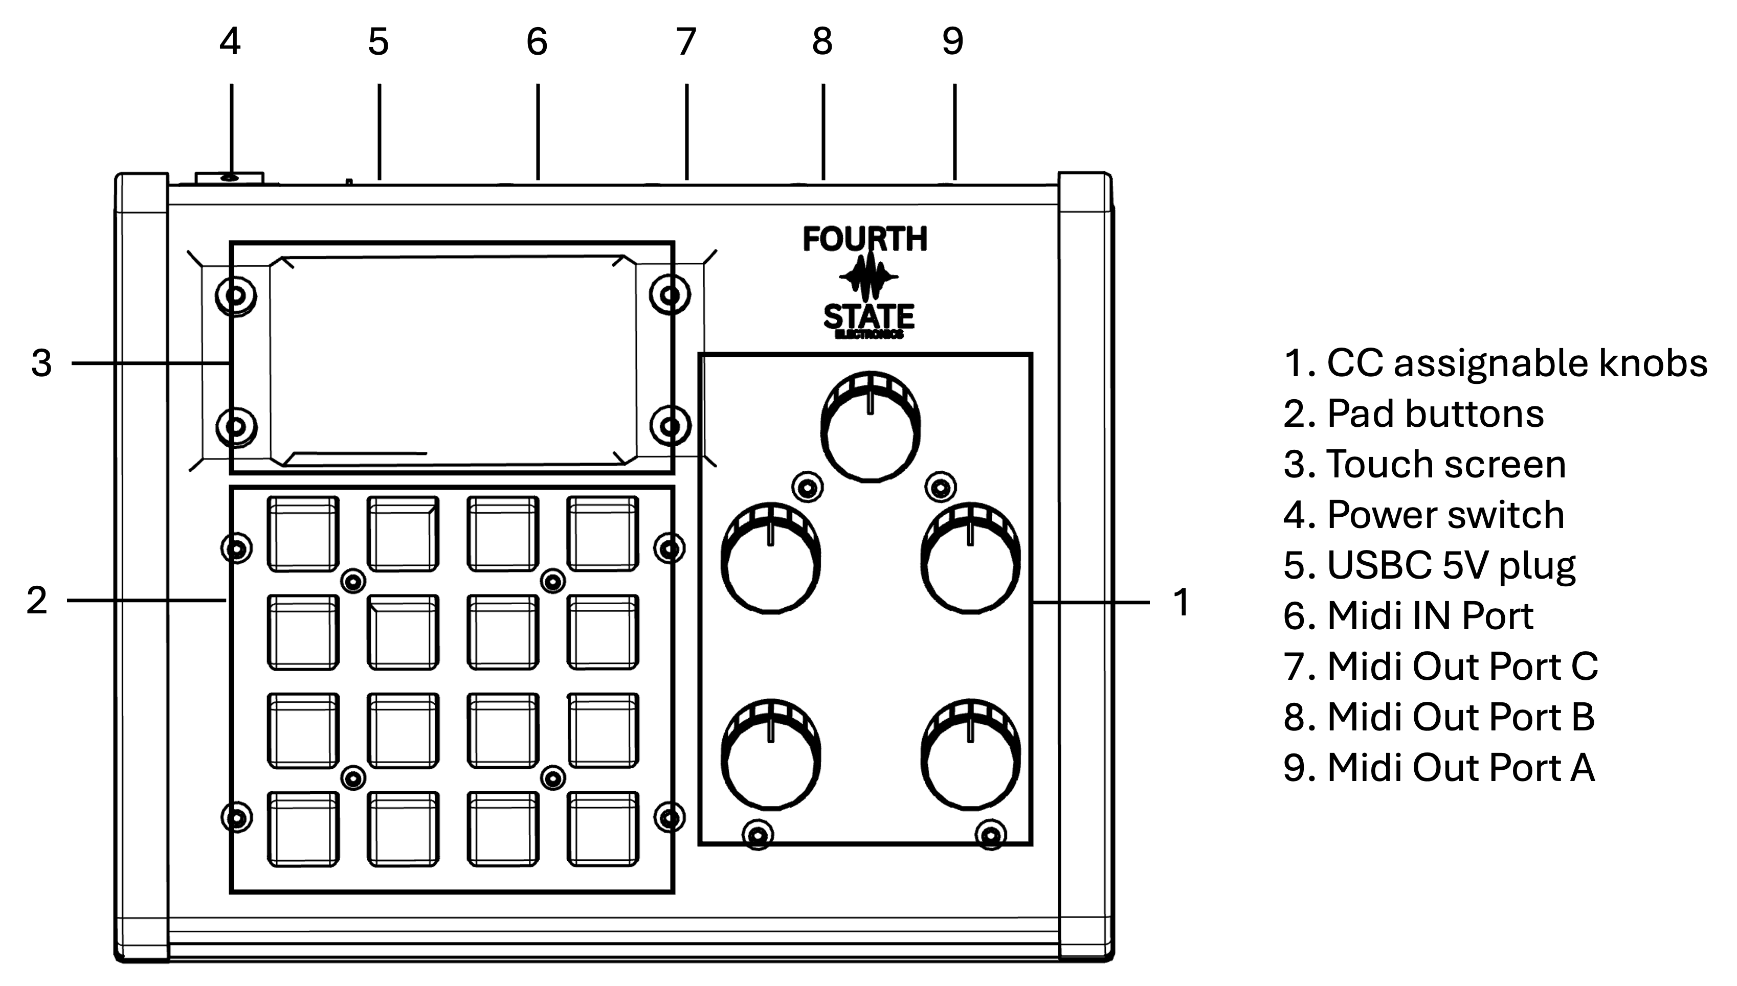

5 The Live Screen

The Live screen is the FSE 1's home base. This is the display you will see 99% of the time. It shows the currently active preset, real-time MIDI routing across all three output ports, and the current position of every physical knob. All navigation to other screens starts here.
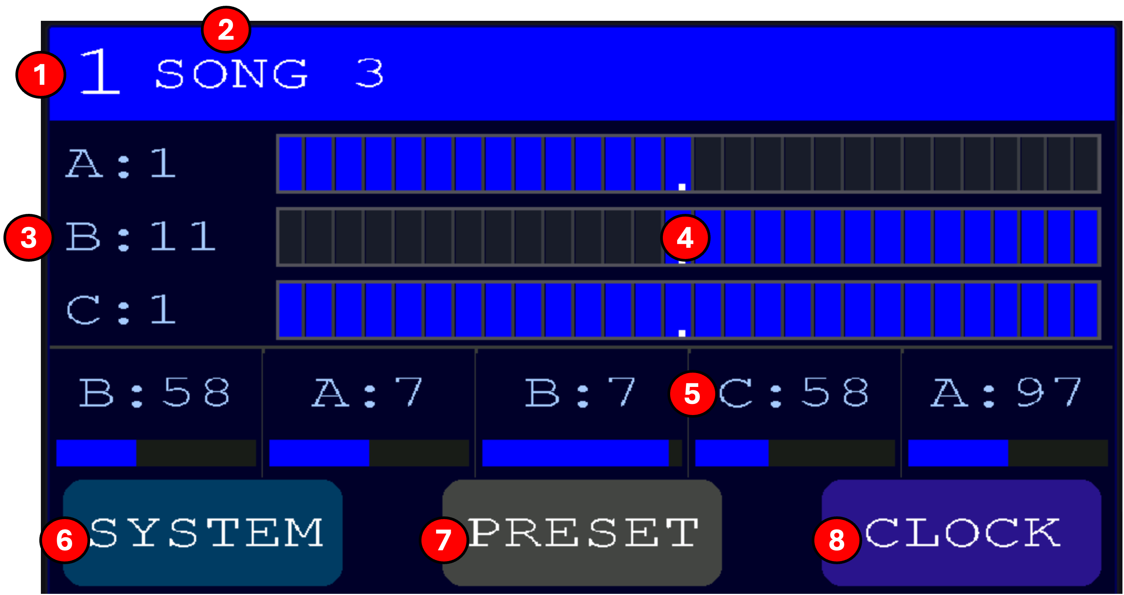
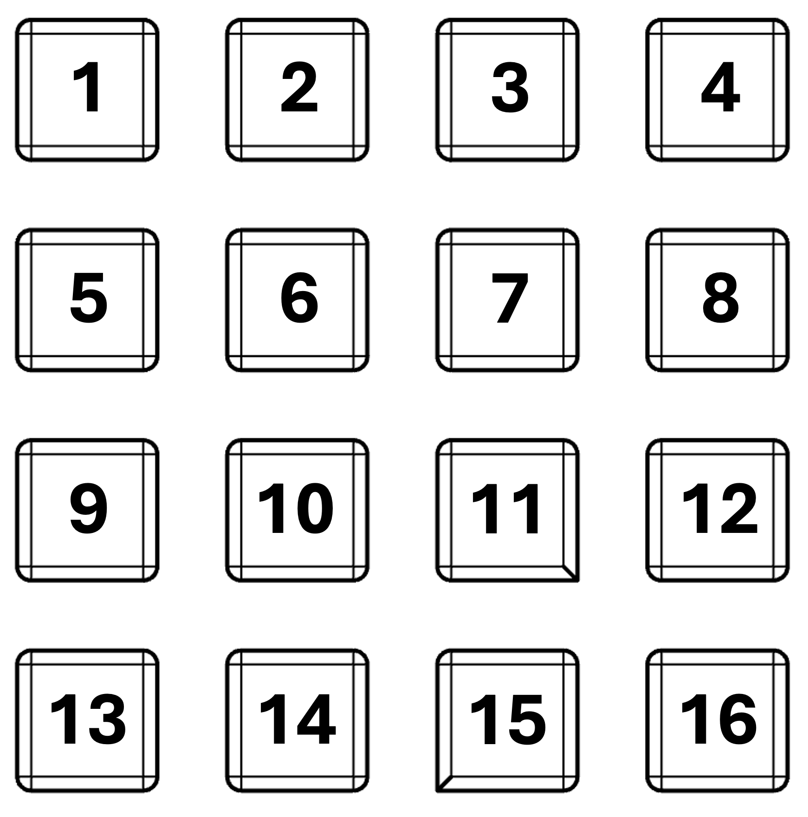

Screen elements
(1) Preset number
The currently loaded preset (1–16). Changes instantly when you tap a different button.
(2) Preset name
The name assigned to this preset in the Name editor. Blank if the preset has not been named.
(3) Port zone bars (A, B, C)
One row per output port. The label shows the port letter and its Program Change number.
(4) Zone indicator
The bars are representations of a 128-key piano which help you visualize the zones of each device. Bright cells are notes that route through this port; dark cells are filtered out. A full bar means All mode; a partial bar means Zone mode; a dark bar means the port is muted for this preset. The small dot inside each port bar marks Middle C (MIDI note 60). A fixed reference to help you read zone boundaries at a glance.
(5) Knob level bars (K1–K5)
Five compact bars showing each physical knob's port, CC number, and current MIDI value. Updates in real time as you turn each knob.
(6) SYSTEM button
Opens the Config screen; global settings, brightness, bank save/load, About, and Features. (See system configuration section)
(7) PRESET button
Opens the Preset Editor for the currently loaded preset. (See preset section)
(8) CLOCK button
Opens the Clock screen; sets internal BPM, chooses clock source, and selects which ports transmit MIDI clock. (See clock section)

Front-panel buttons (Fig. 2)
(0) Pads 1–16
The 16 backlit pads across the front of the unit map directly to the 16 presets in the current bank. Tap any pad to load that preset and the Live screen will update immediately. Pad color is the color assigned to that preset in the Color editor. (See color section)

Notes
Note. Everything on the Live screen updates in real time: knob turns, incoming Program Changes, pad presses, and clock ticks all refresh the display within a few milliseconds.
Note. A completely dark port bar means the port is in None mode for this preset and any synth connected to that output will not sound but program changes will still occur which is still useful for effect control etc..

6 Button Control

Most edit and configuration screens on the FSE let you change values in two ways: Knob 1 gives fine control, and the 16 buttons become a colored nudge grid. The layout is the same on every screen that uses it, so the muscle memory transfers.
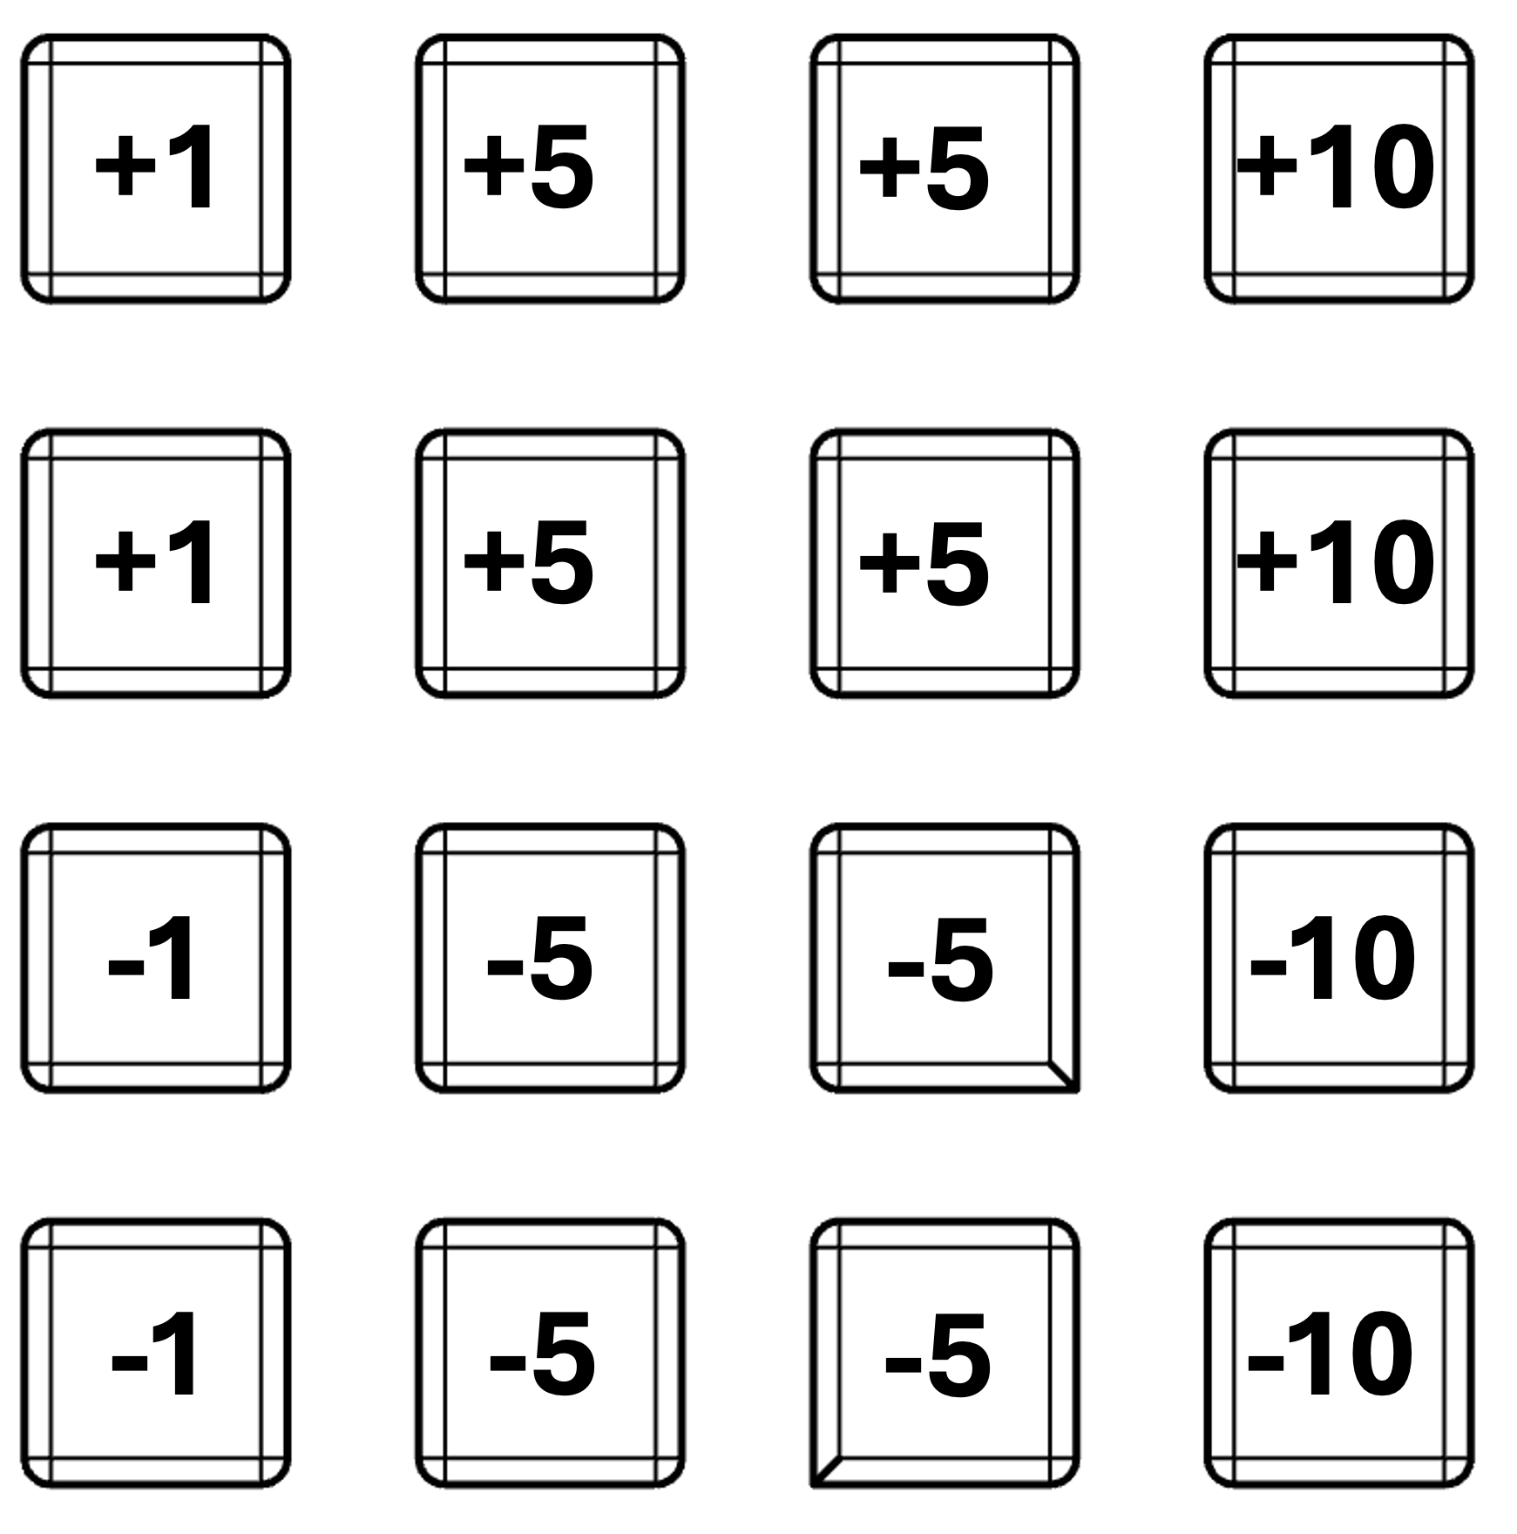

Reading the grid
The grid follows one symmetric rule that combines direction and magnitude:
- Top half of the grid (buttons 1–8): increases the current value.
- Bottom half (buttons 9–16): decreases it.
- Left column (1, 5, 9, 13): ±1 per press. Fine control.
- Middle two columns (2, 3, 6, 7, 10, 11, 14, 15): ±5 per press.
- Right column (4, 8, 12, 16): ±10 per press. Coarse control.
Every press has the same effect as turning Knob 1 by that many detents in the corresponding direction. LEDs light green in the top half and amber in the bottom, with brightness scaling to reflect magnitude so at a glance you can see which button will make how big a change.

Where button control is active
The nudge grid lights up whenever you are on one of these screens:
- Program editor
- Knob editor
- Tuning editor
- Velocity editor
- Arp editor
- MIDI Filter editor
- Chord editor
- Config (System) screen
- Load Bank screen

Where button control is not active
Two screens deliberately re-use the buttons for a different purpose:
- Clock screen, the 16 buttons become a tap-tempo surface. Knob 1 still gives fine BPM control.
- Color and Name editors, the buttons are the color swatches or keyboard letters themselves, not nudge controls.

7 Editing Presets

Tap PRESET on the Live screen to open the Preset Editor, a grid of tiles for editing every aspect of the currently loaded preset. Each tile opens a dedicated editor. Tap CANCEL to return to Live.
The Preset Editor is a grid of tiles for editing every aspect of the currently loaded preset. Reach it by tapping the PRESET button on the Live screen. Each tile opens a dedicated editor for one facet of the preset from routing and knobs to optional features like tuning, arp, and chord. Tap CANCEL to return to Live without saving changes. Tuning, velocity, arp, fiter and chord can be configured to not show up in this menu through the feature screen in the systems tab. This is useful if signal processing is not required for your setup and you would like to simplify your preset editing. (see feature section).
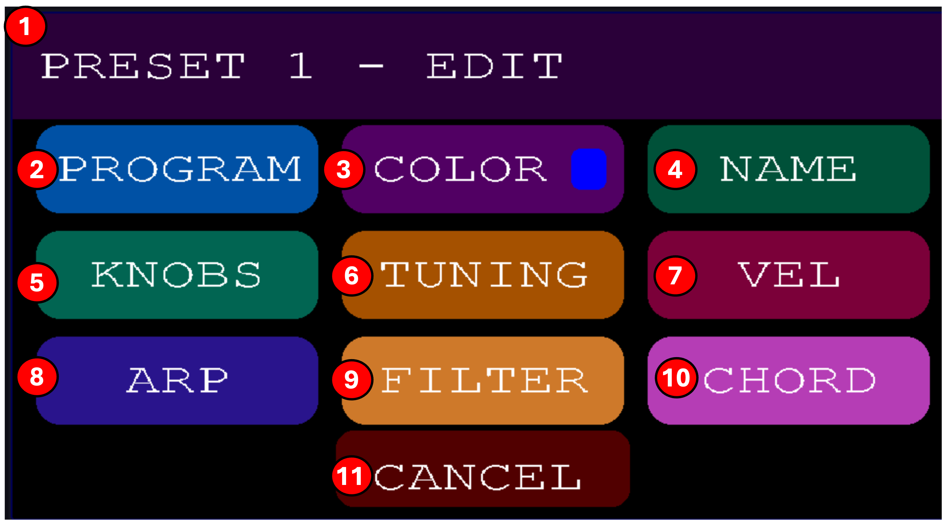

Tiles
(1) Header banner
Shows the preset number currently being edited and confirms you're in EDIT mode. All changes on the following screens apply to this preset only.
(2) PROGRAM
Opens the Program editor. This is where you define what each of the three output ports (A, B, C) does for this preset, routing mode, note zones, and the Program Change number sent when the preset loads.
(3) COLOR
Opens the Color picker. Sets the pad color for this preset, the swatch shown next to the label previews the current choice.
(4) NAME
Opens the on-screen keyboard for renaming this preset. The name is shown on Live and in the Bank Builder web app.
(5) KNOBS
Opens the Knob editor. Assigns each of the five physical knobs to a CC number, port, and initial value for this preset.
(6) TUNING
Opens the Tuning editor. Enables microtonal scales for this preset.
(7) VEL
Opens the Velocity Curve editor. Shapes how incoming keyboard velocity is mapped to outgoing note velocity for this preset. Only visible when the Velocity feature is on.
(8) ARP
Opens the Arpeggiator editor. Configures per-port arp pattern, rate, and octave range for this preset. Only visible when the Arp feature is on.
(9) FILTER
Opens the MIDI Filter editor. Blocks specific incoming CCs, PC, PB, or aftertouch messages per port. Only visible when the MIDI Filter feature is on.
(10) CHORD
Opens the Chord Generator editor. Turns single incoming notes into full chords per port. Only visible when the Chord Generator feature is on.
(11) CANCEL
Returns to the Live screen. Any preset changes made in the editors on this grid are saved as they are made

Notes
The grid is dynamic, tiles for optional features (Tuning, Velocity, Arp, Filter, Chord) only appear when their feature is enabled in the Features screen (SYSTEM → FEATURES). If a tile is missing, turn on its feature to reveal it. The layout automatically rearranges to fill the screen based on how many tiles are visible.
See the individual editor sections of this manual for detailed docs on each tile.

7.1 Program
The Program editor defines what each of the three output ports (A, B, C) does when this preset loads, the Program Change message sent, note transposition, note-range routing mode, and the zone boundaries.
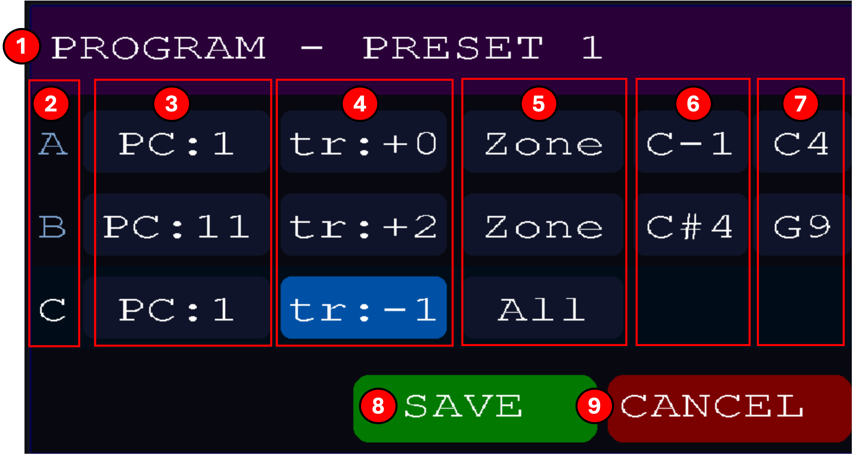

Screen elements
(1) Header
Confirms which preset is being edited.
(2) Port column (A, B, C)
One row per output port. All settings on that row apply to that port only.
(3) PC (Program Change)
Program Change number transmitted on this port when the preset loads (1–128). Use this to auto-recall patches on your synths.
(4) Transpose (tr)
Number of semitones added to every note routed through this port. Negative values transpose down.
(5) Mode
How the port responds to notes from the master keyboard: All (every note passes), Zone (only notes within the range below pass), None (port is muted for this preset). If latch is enabled in the features window Alat and Zlat are enabled which allows either all keys (Alat) or a selected range (Zlat) to be passed and also latched (notes held down after physically released).
(6) Zone low note
In Zone mode, the lowest note (inclusive) that will route through this port. Not present in All and None modes.
(7) Zone high note
In Zone mode, the highest note (inclusive) that will route through this port. Not present in All and None modes.
(8) SAVE
Writes the changes to the preset and returns to the Preset Editor.
(9) CANCEL
Discards changes and returns to the Preset Editor.

Notes
Note. Zone mode is the basis of keyboard splits, set Port A to a bass range and Port B to a lead range on the same preset for an instant split.

7.2 Color
The Color editor sets the pad and screen palete color for each preset.
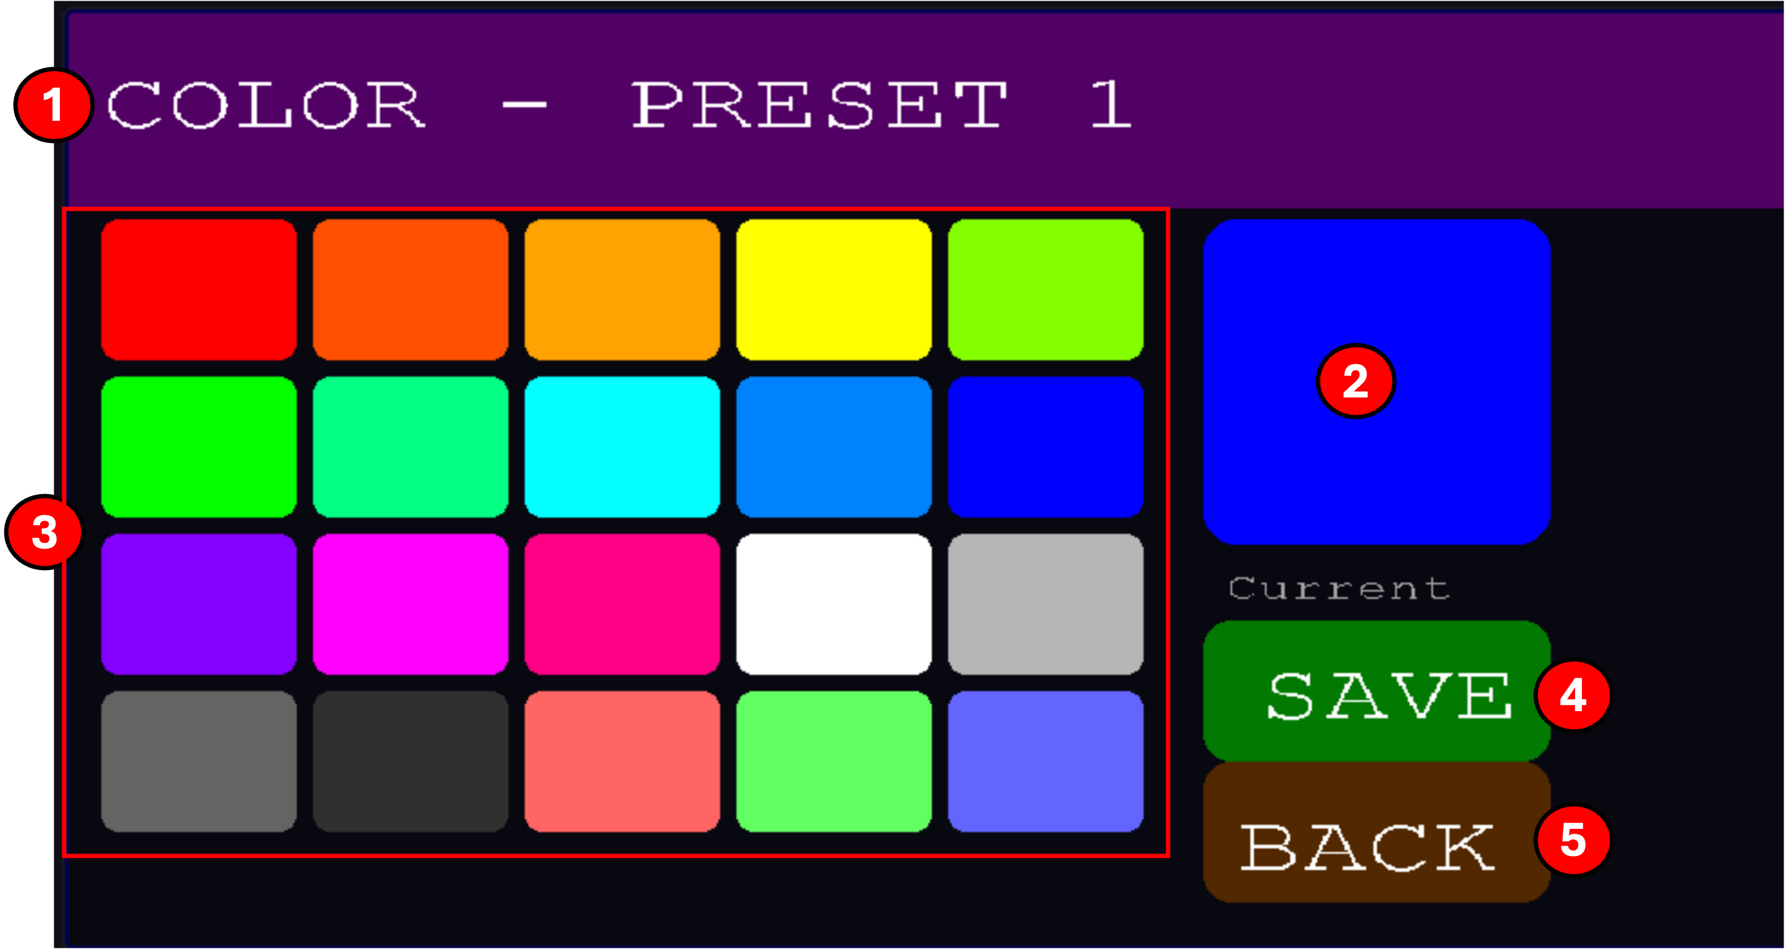

Screen elements
(1) Header
Confirms which preset is being edited.
(2) Current color preview
A large swatch showing the color currently selected for this preset.
(3) Color palette
20 preset color swatches. Tap any swatch to preview it, the current-color box updates immediately, and the front-panel pad for this preset lights up in the new color as well.
(4) SAVE
Writes the selected color to the preset and returns.
(5) BACK
Discards the color change and returns to the Preset Editor.

7.3 Name
The Name editor lets you assign a text label to the current preset. The name is shown on the Live screen and in the Bank Builder web app.
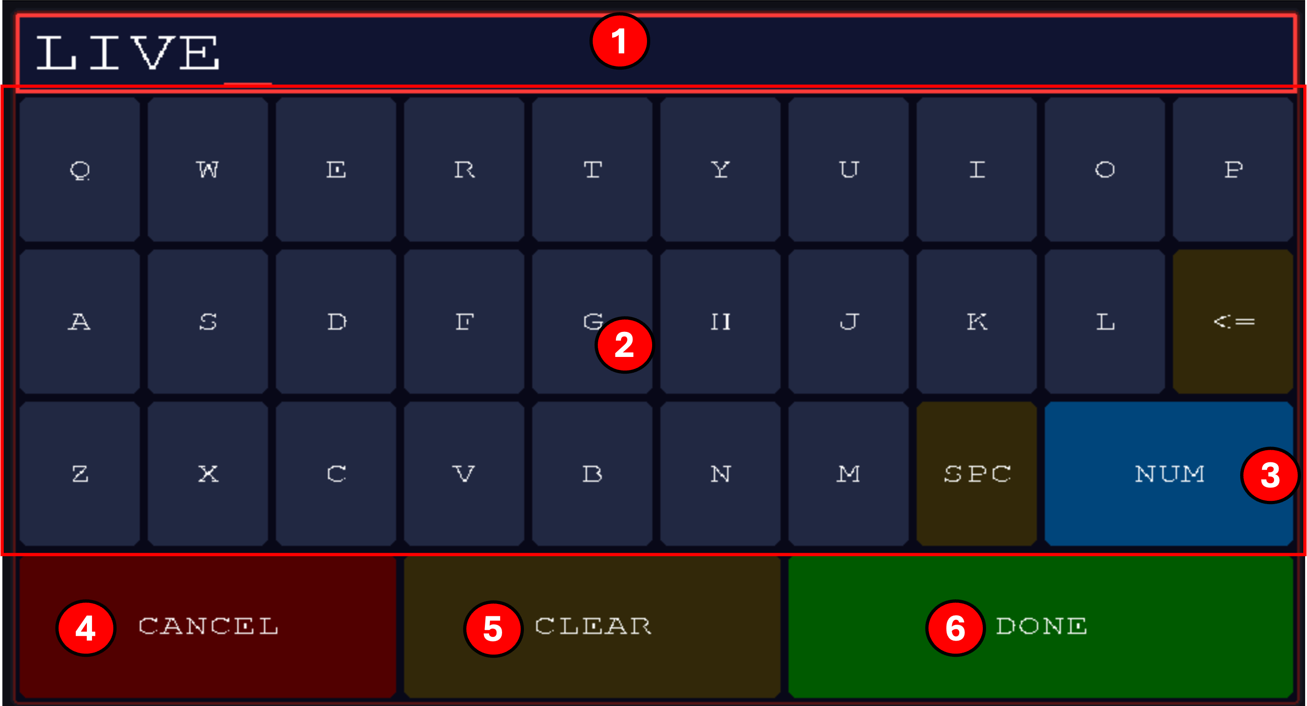

Screen elements
(1) Name display
The name being edited. Shows a cursor at the current insertion point.
(2) Keyboard
On-screen QWERTY keyboard. Tap any letter to insert it. Backspace (⇐) removes the last character; SPC inserts a space.
(3) NUM
Switches the keyboard between letters and a number/symbol layout for typing digits and punctuation.
(4) CANCEL
Discards changes and returns to the Preset Editor.
(5) CLEAR
Erases the entire name in one tap.
(6) DONE
Saves the name to the preset and returns.

Notes
Note. Preset names are stored per-preset per-bank, renaming a preset in one bank does not affect its name in another bank.

7.4 Knobs
The Knobs editor is a two-step editor for assigning each of the five physical knobs to a MIDI CC number and output port for the current preset. First screen is a knob picker; second screen edits the picked knob.
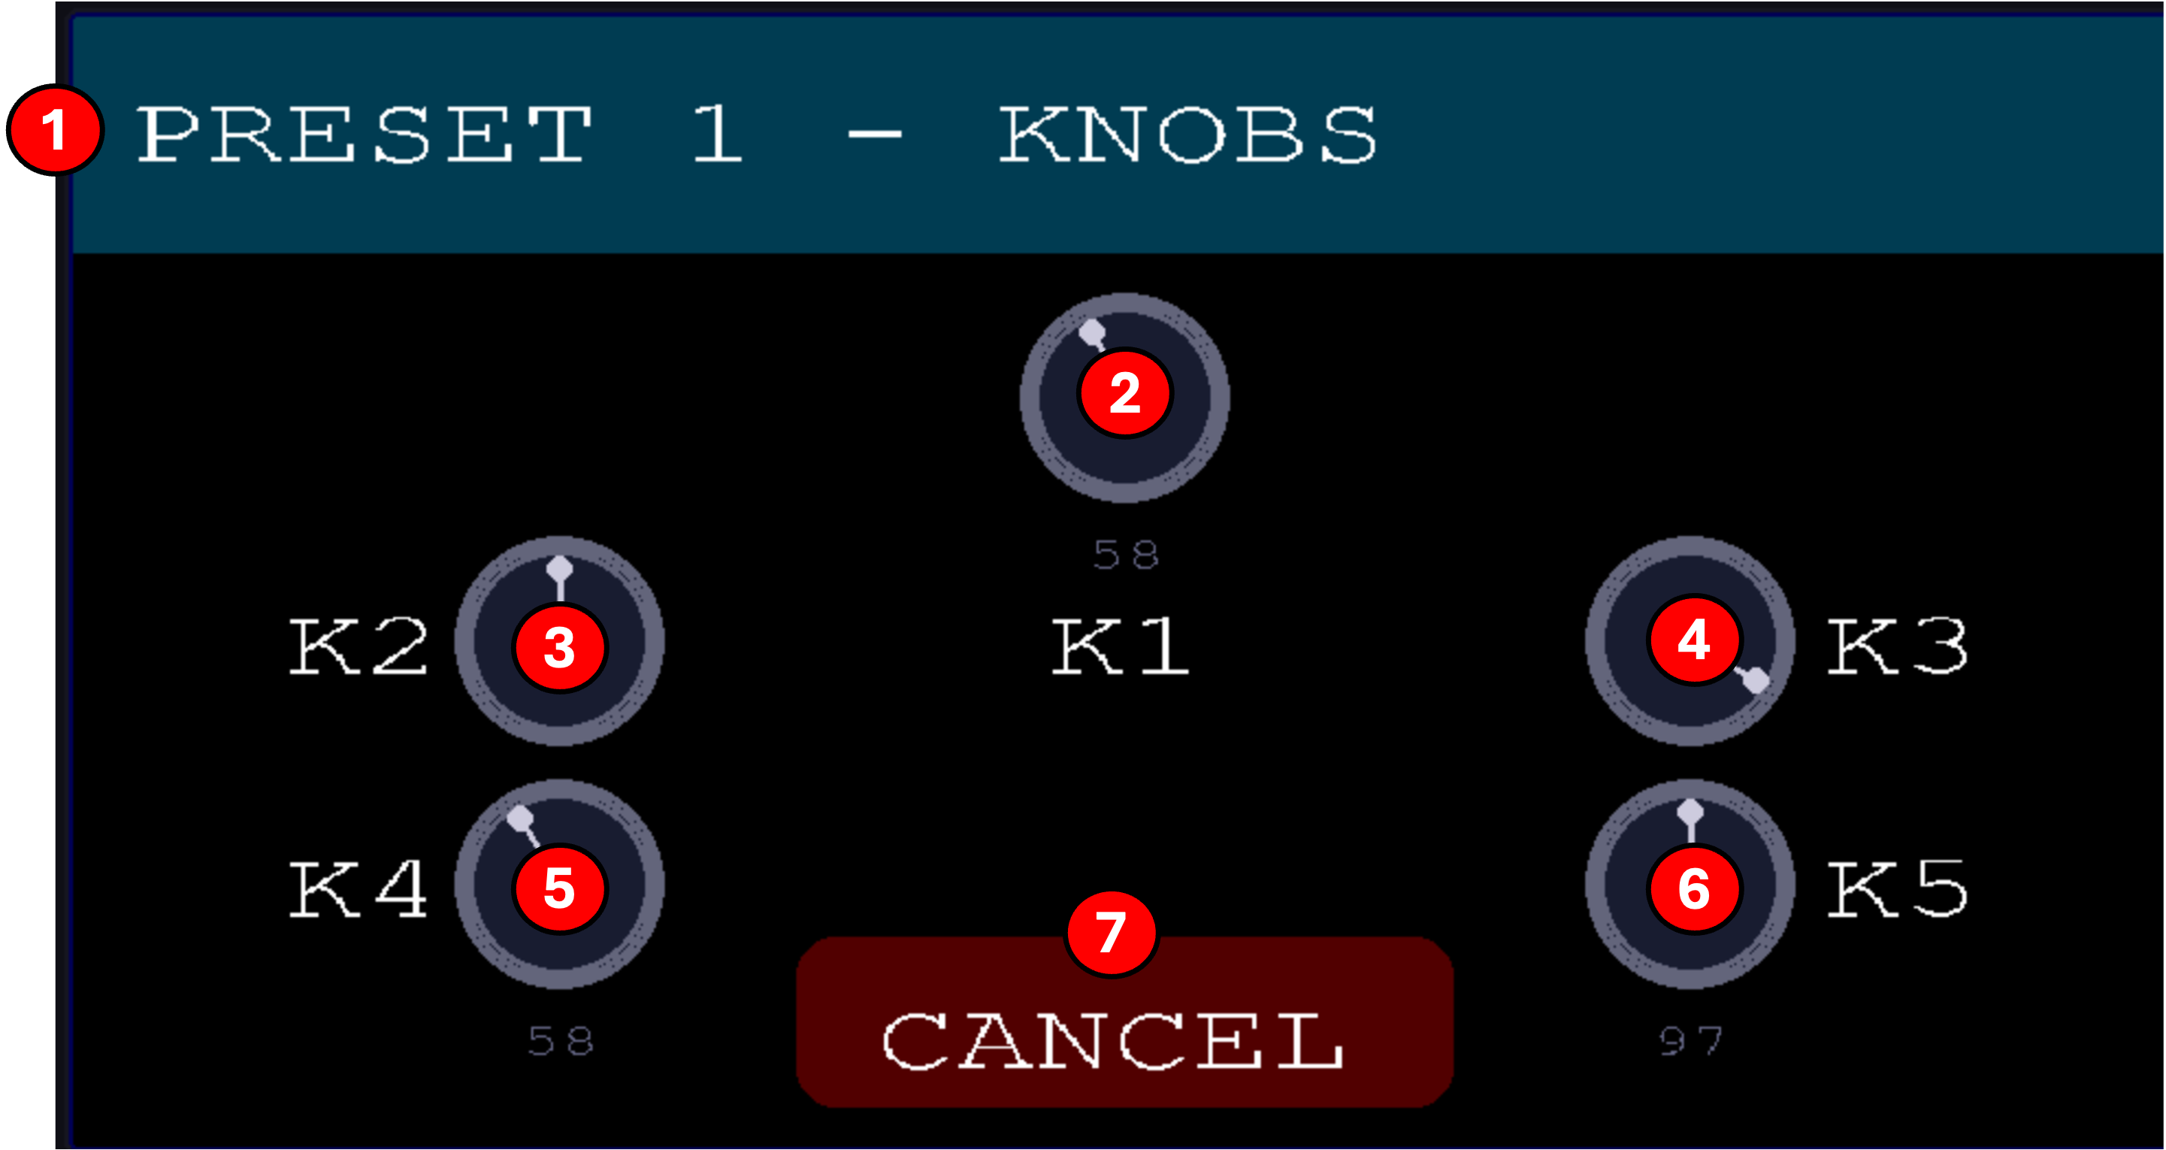

Knob picker
(1) Header
Confirms which preset is being edited.
(2) K1 (top center)
Tap to open the edit screen for physical knob 1 (top-center on the front panel).
(3) K2 (upper left)
Tap to edit the assignment of physical knob 2.
(4) K3 (upper right)
Tap to edit the assignment of physical knob 3.
(5) K4 (lower left)
Tap to edit the assignment of physical knob 4.
(6) K5 (lower right)
Tap to edit the assignment of physical knob 5.
(7) CANCEL
Returns to the Preset Editor.
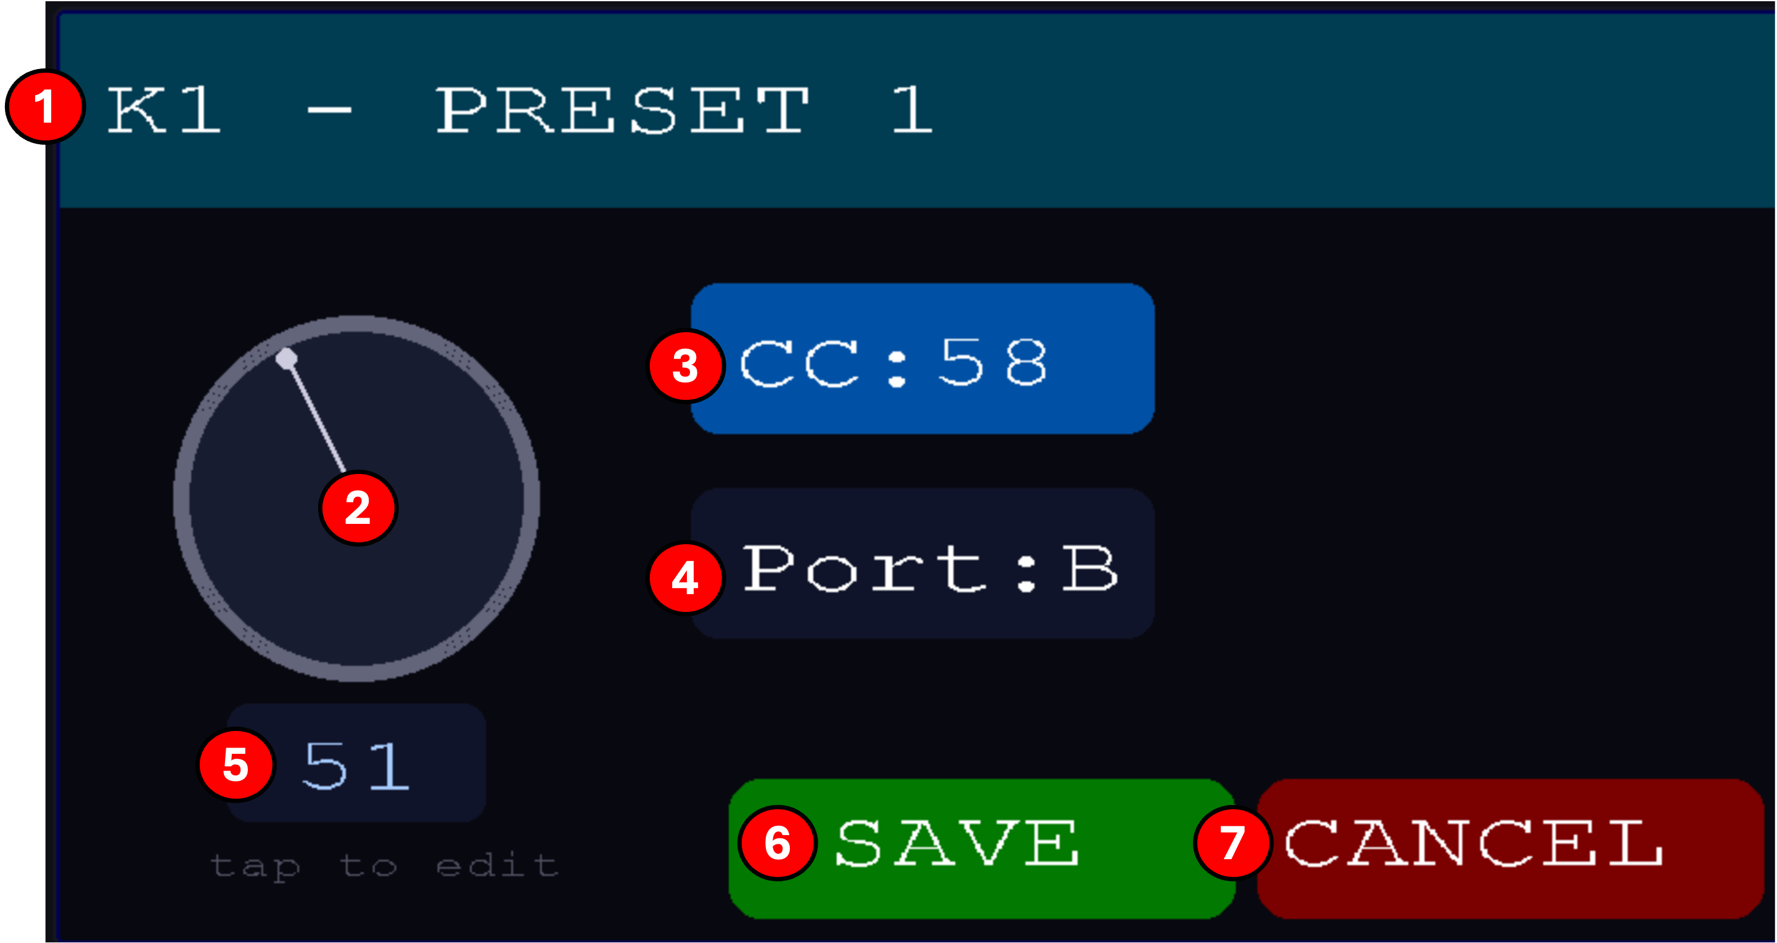

Knob edit screen
(1) Header
Shows which knob is being edited and which preset.
(2) Live position indicator
A visual dial showing the current physical position of this knob in real time. When saved, this will be the initial condition that the knob will go to when the preset is chosen. (5)
(3) CC
The MIDI CC number this knob transmits (0–127). Tap, use Knob 1 or buttons to change.
(4) Port
The output port this knob transmits on (A, B, or C). Tap, use Knob 1 or buttons to change.
(5) Value
The stored starting value the knob will transmit when the preset loads. Also shows the current live value being sent. This allows you to save a setting that is independent of the current position of the physical knob which allows you to reliably reset and restore preset initial sound
(6) SAVE
Writes the CC, port, and starting value to the preset and returns to the knob picker.
(7) CANCEL
Discards changes and returns to the knob picker.

Notes
Note. Physical knobs use pickup mode, after loading a preset, you must sweep each knob past its stored value before it starts transmitting. This prevents sudden CC jumps when switching presets.

7.5 Optional Features
The following editors appear in the Preset Editor grid only when their corresponding toggle is enabled in the Features screen (SYSTEM → FEATURES). Turning a feature off hides its tile and bypasses the feature on every preset, but the underlying saved settings are preserved, so turning the feature back on restores everything.

7.5.1 Tuning
The Tuning editor assigns a microtonal or alternate scale to each output port for the current preset. Every port can run its own scale independently, for example, you can drive a synth on port A in standard 12-EDO while port B plays a Pythagorean bass and port C runs 19-EDO leads.
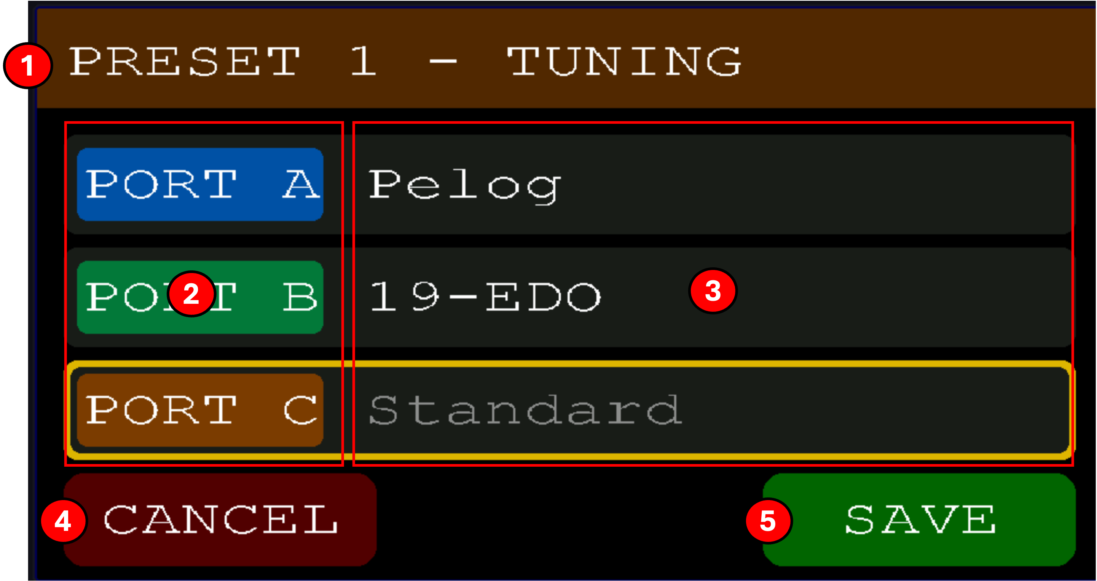

Screen elements
(1) Header
Confirms which preset is being edited.
(2) Port selector (A, B, C)
One row per output port. Each port can run its own independent tuning.
(3) Scale name
The scale currently assigned to this port. Tap to open a list of available scales.
(4) CANCEL
Discards changes and returns.
(5) SAVE
Writes the tunings to the preset and returns.

Available tunings
Nine built-in scales ship with the firmware. Each can be assigned per port, per preset. Standard is the default and bypasses the retuning engine entirely.
- Standard, 12-tone equal temperament. The default Western tuning, every note on a piano keyboard, octave split into 12 equal semitones (100 cents each). Use this when driving a synth that expects standard MIDI.
- 19-EDO, Octave divided into 19 equal steps (~63 cents each). Major thirds sound noticeably purer than 12-EDO, and enharmonic pairs like C♯ and D♭ become genuinely distinct notes. A staple of xenharmonic and experimental composition; comfortable to explore because familiar diatonic scales still work.
- 24-EDO, Quartertones. The octave divided into 24 equal steps (50 cents apart), twice the resolution of standard tuning. Used in Arabic classical music, some contemporary classical works, and by anyone chasing blue notes between the keys.
- Just Intonation, 5-limit intervals built from simple integer ratios (3:2 fifths, 5:4 major thirds, etc.). Triads lock into place with no beating in the home key, giving chords an almost pre-recorded consonance. The trade-off: modulating away from the home key produces increasingly dissonant intervals. The classic tuning of unaccompanied vocal music.
- Bohlen-Pierce, A non-octave scale: the period is a tritave (3:1 frequency ratio, ~1902 cents) divided into 13 equal steps. There are no octaves at all, traditional major/minor harmony does not apply. Sounds alien and airy, and has been explored heavily in electronic and computer music since the 1970s.
- Pythagorean, 12 notes built entirely from stacked perfect fifths (3:2 ratios). Fifths and fourths are pure; major thirds are wider and more restless than in 12-EDO. Historically the tuning of medieval European chant and early Islamic music theory. Excellent for open-fifth and quartal harmony.
- 31-EDO, Octave divided into 31 equal steps (~38.7 cents each). Approximates 5-limit just intonation exceptionally well, better than 19-EDO, making meantone-style harmony sound especially locked-in. Historically championed by Christian Huygens and, later, the Dutch composer Adriaan Fokker.
- Slendro, A 5-note tuning from Javanese and Balinese gamelan music, roughly equal steps of ~240 cents. No leading tones or dominant pull; melodies feel floating and cyclical rather than directional. This firmware uses a Wilson approximation; real gamelans vary tuning significantly by ensemble.
- Pelog, A 7-note gamelan scale with distinctly unequal spacing, small steps clustered together, then large leaps. Traditionally only 5 of the 7 notes are used in any given piece (via mode selections called pathet). Evocative and unresolved compared to Western tunings.

Notes
Note. Tuning is delivered as a pitch-bend paired with each note-on, so the receiving synth must respond to pitch-bend for the retuning to be audible. If microtonal intervals sound too small on the target synth, increase its pitch-bend range.
Note. Chord voicings in any non-standard tuning are approximate. MIDI tracks only one pitch-bend value per channel, so all sounding notes end up sharing whichever tuning offset the most-recently-played note used. Lead lines, melodic parts, and single-note phrases stay perfectly in tune. Standard (12-EDO) is not affected by this limitation because it sends no pitch-bend at all. Per-voice MPE routing is not currently supported.

7.5.2 Velocity
The Velocity editor reshapes how incoming keyboard velocity is mapped to outgoing note velocity, per output port. Useful for taming or exaggerating dynamics on a particular synth without changing your playing.
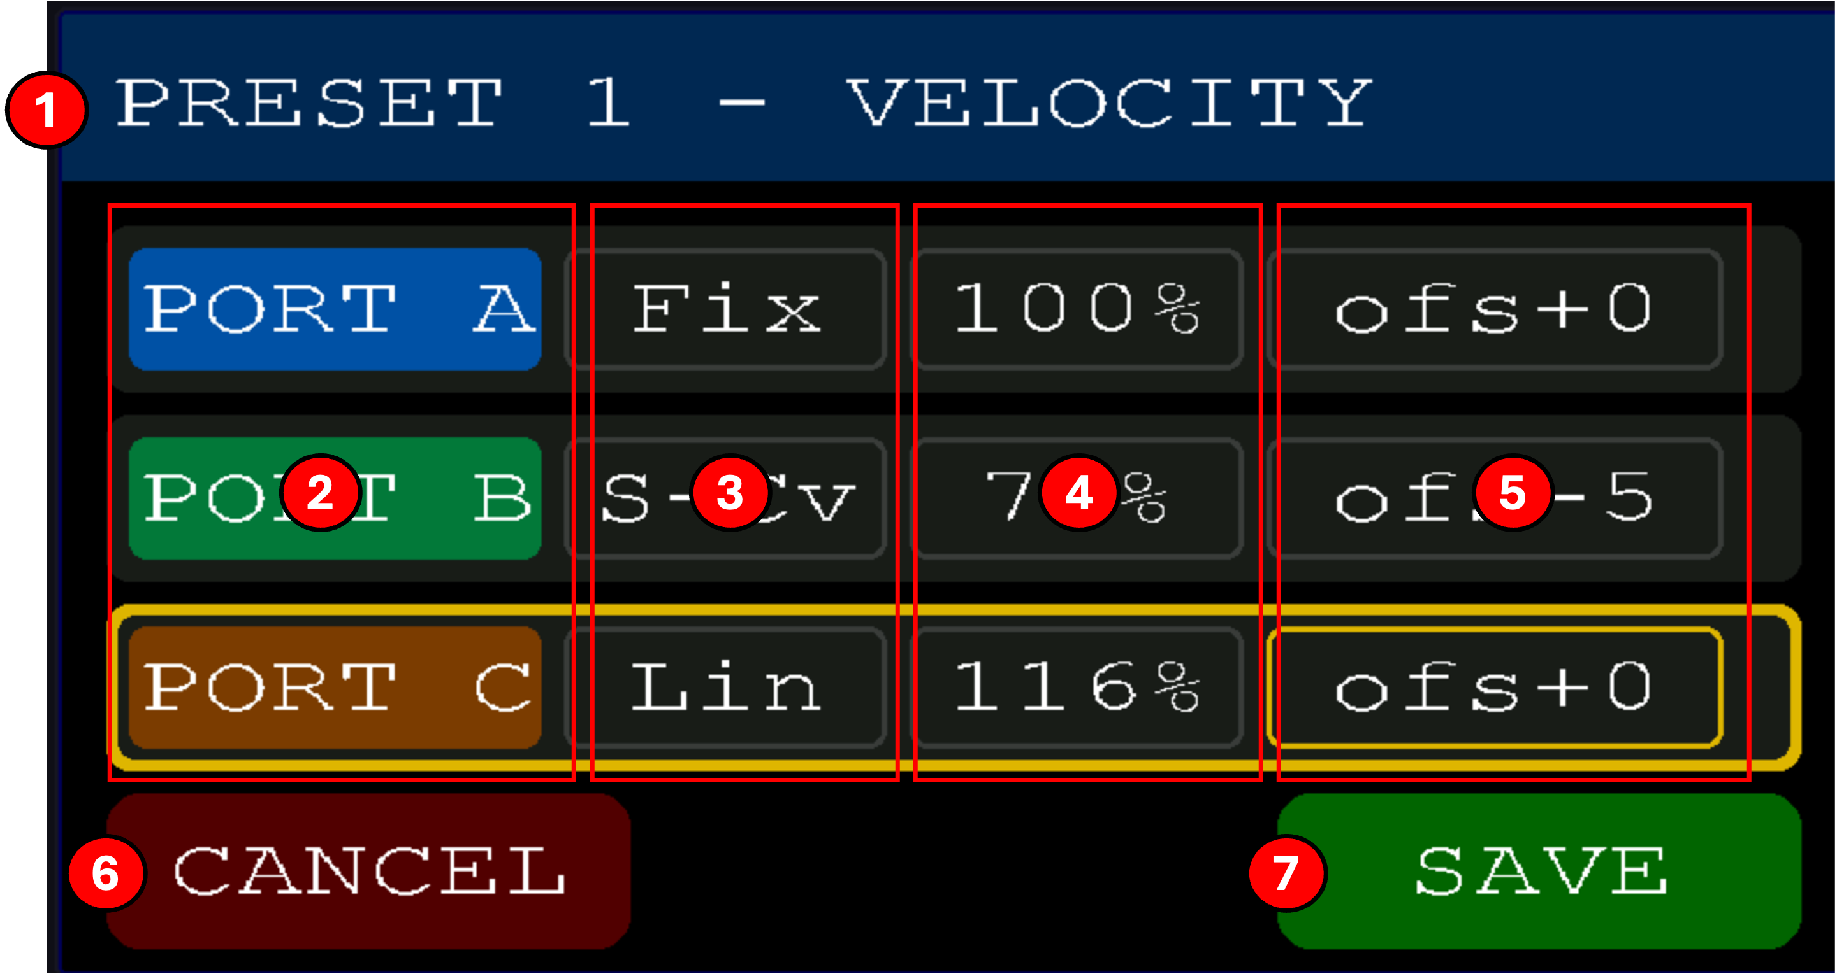

Screen elements
(1) Header
Confirms which preset is being edited.
(2) Port selector (A, B, C)
One row per output port. Each port has its own independent curve, gain, and offset.
(3) Curve type
The shape of the velocity mapping: Lin (linear pass-through), S-Cv (S-curve, compresses extremes), Fix (fixed output regardless of input), and additional curve types.
(4) Gain
Overall scaling percentage applied after the curve. 100% is unity.
(5) Offset
Constant added to the final velocity. Positive raises the floor, negative lowers the ceiling.
(6) CANCEL
Discards changes and returns.
(7) SAVE
Writes the settings to the preset and returns.

7.5.3 Arpeggiator
The Arpeggiator editor configures a per-port arpeggiator for the current preset. Each of the three output ports can run its own independent arpeggiator, driven by internal clock or external MIDI clock. Internal or external clock mode is set through the clock screen. (see clock section)
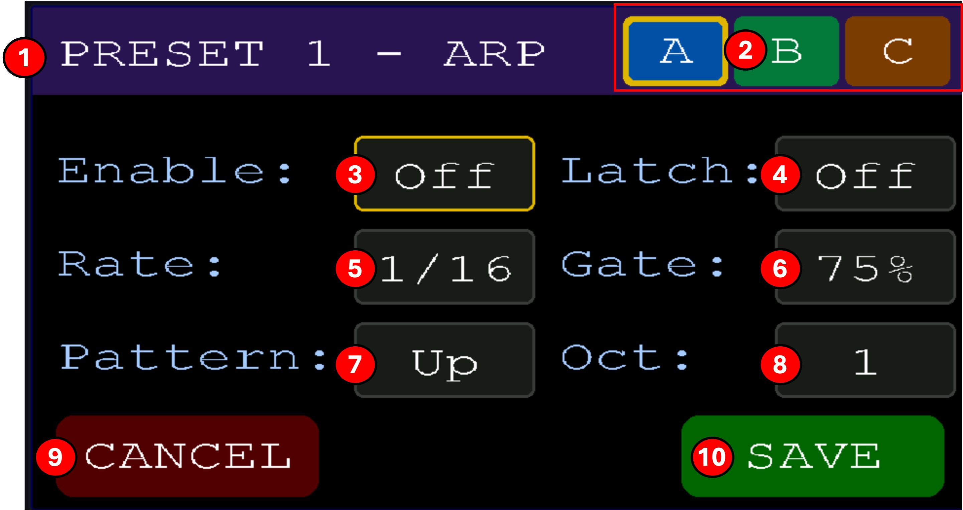

Screen elements
(1) Header
Confirms which preset is being edited.
(2) Port tabs (A, B, C)
Tap to switch which output port's arpeggiator you're editing. The highlighted tab is active.
(3) Enable
Master on/off for the arp on this port. When off, notes pass through untouched.
(4) Latch
When on, held notes continue arpeggiating after you release them, until you play a new note or press CANCEL/PANIC.
(5) Rate
Step length as a musical note value (1/4, 1/8, 1/16, etc.) synced to the current clock.
(6) Gate
Percentage of each step during which the note sounds. Lower values are staccato, higher values are legato.
(7) Pattern
Note order, Up, Down, Up-Down, Random, and other pattern types.
(8) Octaves
How many octaves the pattern spans above the held notes.
(9) CANCEL
Discards changes and returns.
(10) SAVE
Writes the settings to the preset and returns.

Notes
Note. The arpeggiator respects the port's tuning and velocity settings, enable a microtonal scale on Port A and its arp will play in that scale.
Note. Zoning gates which notes enter the arpeggiator buffer. Once a note is held and being arpeggiated, the octave-range expansion can carry the pattern above the zone, the only limit is MIDI 127.

7.5.4 MIDI Filter
The MIDI Filter editor lets you block specific incoming MIDI messages from being forwarded through each output port. Useful when your master keyboard sends CCs, program changes, or aftertouch that a downstream synth doesn't handle well. Additionally, this can be useful if you have a modulation like a sustain pedal on the master keyboard and don’t want it translated to another (CC 64)
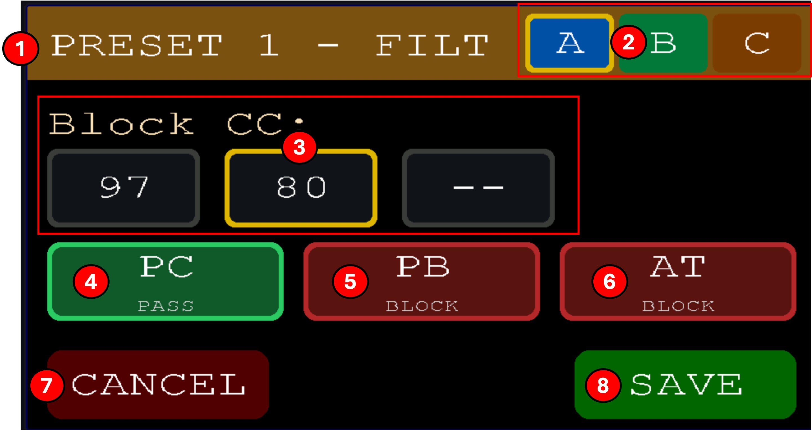

Screen elements
(1) Header
Confirms which preset is being edited. The banner shows FILT (a shortened form of FILTER used to keep the port tabs on-screen).
(2) Port tabs (A, B, C)
Tap to switch which output port's filter you're editing.
(3) Block CC slots
Three slots for CC numbers to block on this port. Enter a CC number to block it; leave blank (--) to leave that slot unused. Any incoming CC on this list is dropped before being forwarded.
(4) PC
Whether Program Change messages from the master keyboard pass through this port. Tap to toggle PASS/BLOCK.
(5) PB
Whether Pitch Bend messages pass through this port. Tap to toggle PASS/BLOCK.
(6) AT
Whether Aftertouch (both channel and poly) passes through this port. Tap to toggle PASS/BLOCK.
(7) CANCEL
Discards changes and returns.
(8) SAVE
Writes the filter to the preset and returns.

Notes
Note. Note-on and note-off messages are always forwarded, the filter only affects CC, PC, PB, and aftertouch.

7.5.5 Chord Generation
The Chord Generator turns each single note you play into a full chord on the output. Each port has its own independent chord type, so you can layer, for example, a Maj7 on Port A with a Sus4 on Port B playing simultaneously from one key.
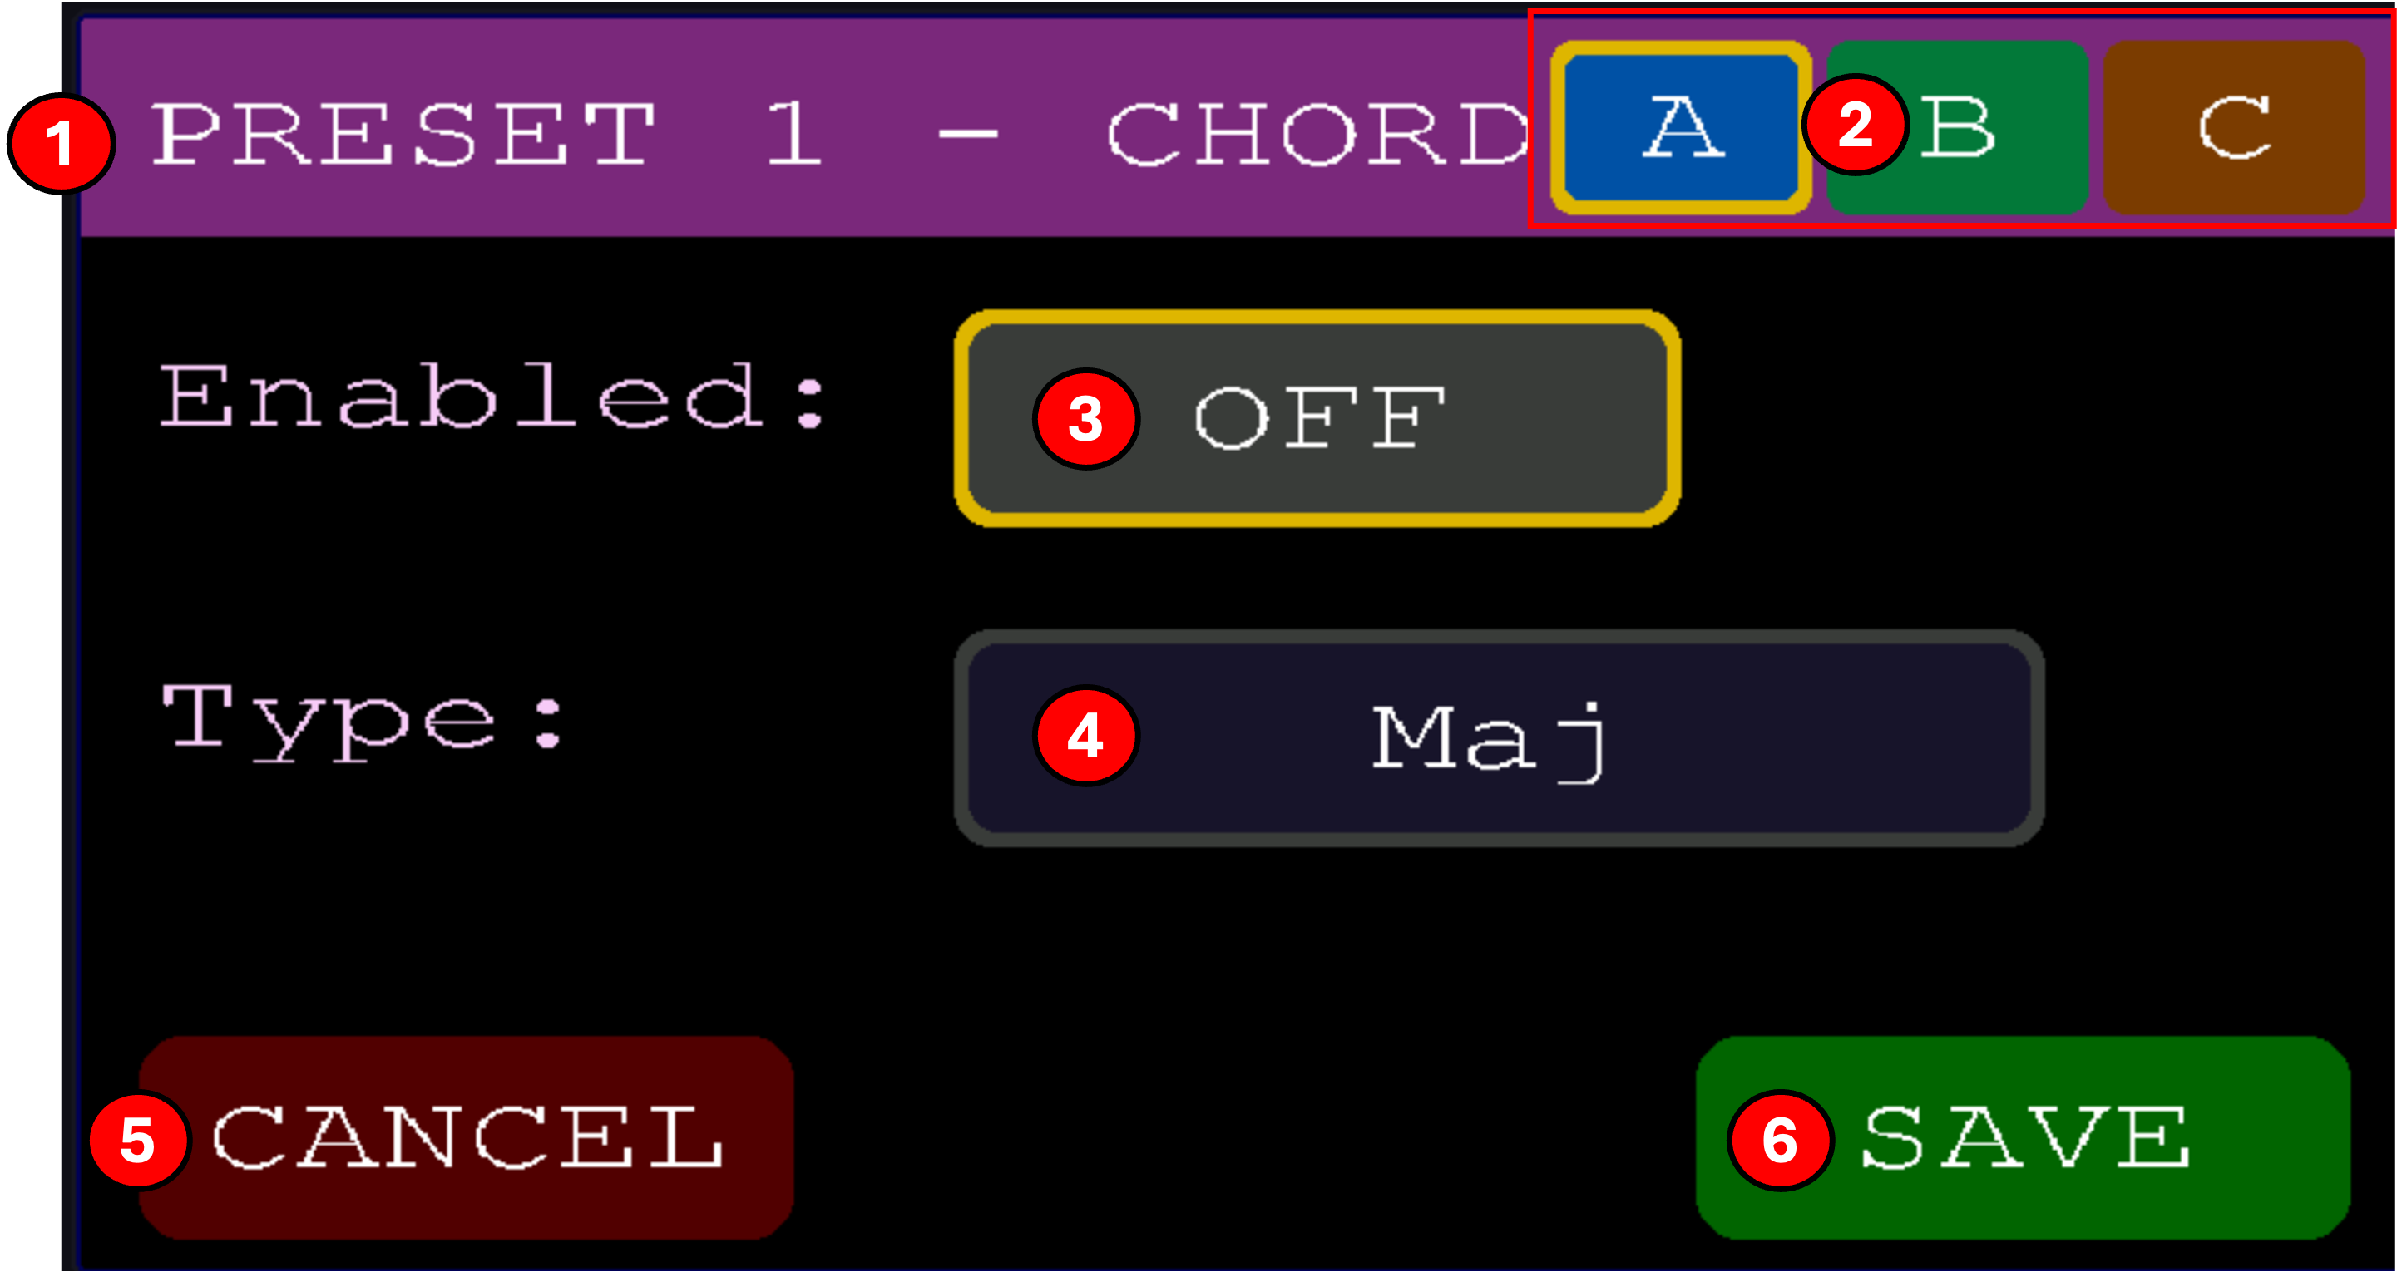

Screen elements
(1) Header
Confirms which preset is being edited.
(2) Port tabs (A, B, C)
Tap to switch which output port's chord settings you're editing.
(3) Enabled
Turns the chord generator on or off for this port. When off, notes pass through untouched.
(4) Type
The chord type built above each played root note. All 12 types are described below.
(5) CANCEL
Discards changes and returns.
(6) SAVE
Writes the settings to the preset and returns.

Available chord types
Twelve chord types ship with the firmware. Each note you play becomes the root, and the selected chord's intervals are stacked above it. Numbers in parentheses list the intervals in semitones from the root.
- Maj, Major triad (0, 4, 7).
- Min, Minor triad (0, 3, 7).
- Sus2, Suspended 2nd (0, 2, 7).
- Sus4, Suspended 4th (0, 5, 7).
- Dim, Diminished triad (0, 3, 6).
- Aug, Augmented triad (0, 4, 8).
- Maj7, Major 7th (0, 4, 7, 11).
- Min7, Minor 7th (0, 3, 7, 10).
- 7, Dominant 7 (0, 4, 7, 10).
- Maj9, Major 9th (0, 4, 7, 11, 14).
- Min9, Minor 9th (0, 3, 7, 10, 14).
- Add9, Major triad plus a 9, no 7th (0, 4, 7, 14).
- Notes
Note. Chord generation happens after tuning and velocity processing, so chord notes are retuned by the per-port scale. However, MIDI pitch-bend is applied per channel, not per note, so in a non-standard tuning, all notes in a chord share the same offset rather than intonating individually.
Note. Chord voicings all play in root position, the root note you press is the lowest note in the chord, with the intervals stacked above it. Because chords are built by adding notes above the root, higher chords (5 notes) leave less headroom before hitting the MIDI ceiling, high input notes with Maj9/Min9 can clip the top note.
Note. Zoning gates the root note only. Once a note passes the port's zone check, the full chord expansion plays, chord notes that fall outside the zone still go out. The only limit on chord output is the MIDI ceiling (127); high roots with Maj9 / Min9 can clip the top note.

7.5.6 Latch
Latch is a global on/off toggle, not a dedicated editor. When enabled, the port-mode picker in the Program editor gains two extra modes: All Latch and Zone Latch. In either latch mode, held notes drone until the next chord. Release the keys and the notes keep sounding; play a new chord to replace them.
Turn latch off from the Features screen and the picker limits itself to None, All, and Zone. Existing latched presets play with the latch behavior translated to their non-latch equivalent, so nothing hangs.

Notes
Note. Any latched chord releases automatically when you tap a preset button. Useful mid-set when you want a droning chord to stop without triggering Panic. The new preset loads normally with its own settings; only the previous latched notes are silenced.
Note. If a latched chord ever refuses to release (a synth ignoring the note-off, a stuck sustain CC), Panic still works: hold buttons 1 and 16 for half a second to silence every port on every channel.

8 System Configuration Screen

The Config screen holds all global settings, MIDI channels, brightness, bank save/load, About, and Features. Reach it by tapping SYSTEM on the Live screen. Settings here apply to the whole unit, not to any single preset.
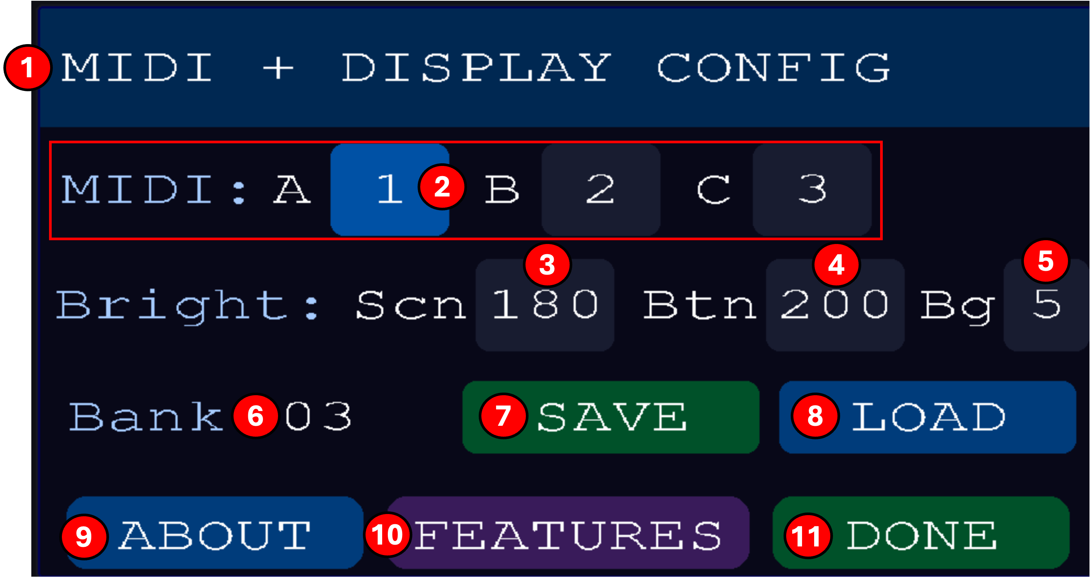

Screen elements
(1) Header
Titled MIDI + DISPLAY CONFIG.
(2) MIDI channels A/B/C
The base MIDI channel used on each output port (1–16). Match these to the receive channels on your connected synths.
(3) Scn (screen brightness)
LCD backlight brightness, 0–255.
(4) Btn (button brightness)
Pad LED brightness, 0–255. This sets the brightness of the selected presets and all other functionality (except background light)
(5) Bg (background brightness)
This sets the brightness of the buttons that are not the selected preset.
(6) Bank number
The bank slot currently loaded (1–16 or higher). Each bank contains its own 16 presets.
(7) SAVE
Saves the currently active in-memory bank to the numbered bank slot shown above.
(8) LOAD
Opens the Load Bank screen so you can pick a different bank slot to load into memory.
(9) ABOUT
Opens the About screen.
(10) FEATURES
Opens the Features screen and allows you to toggle optional per-preset features (Tuning, Vel, Arp, Latch, Filter, Chord) on or off globally.
(11) DONE
Returns to the Live screen. Settings on this screen are saved immediately as you change them.

8.1 SD Card and Banks
The SD card stores up to 16 banks, each holding 16 presets and their names. Files are named BANK01.TTY … BANK16.TTY. Saved in a bank: all 16 presets and their names. Not saved in a bank: MIDI channels, brightness, BPM, clock source, feature toggles, those live in EEPROM.
The Load Bank screen lets you pick a bank slot from the SD card and load its 16 presets into active memory. Reach it via SYSTEM → LOAD. Use either the button pads or the touch screen to load a bank.
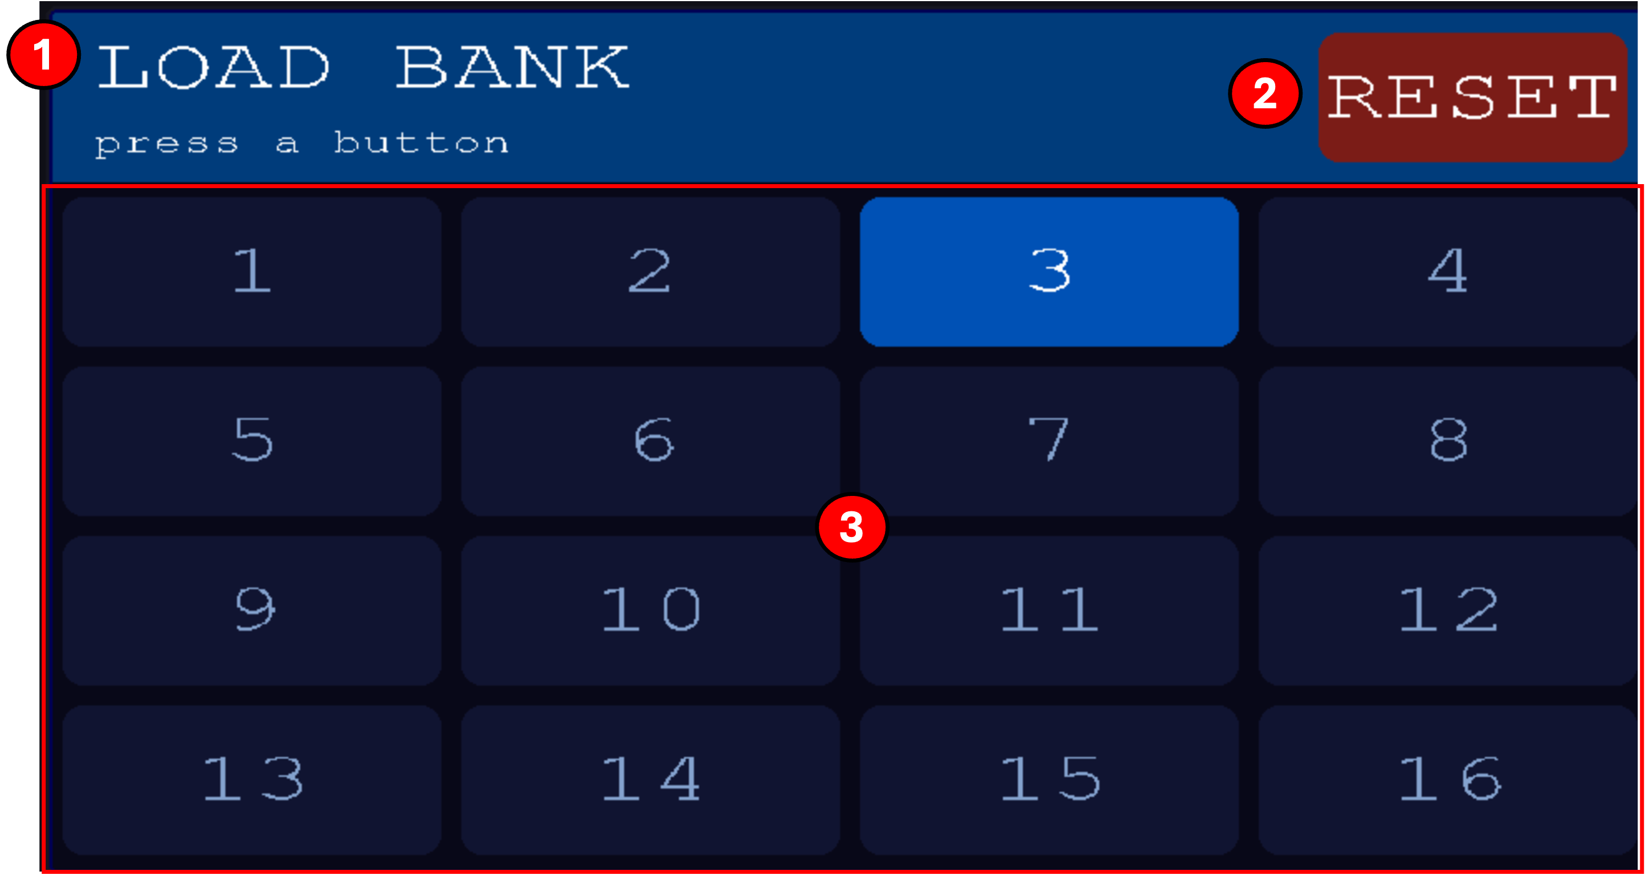

Screen elements
(1) Header
Titled LOAD BANK with a prompt to press a numbered button.
(2) RESET
Restores the current bank slot to its factory-shipped state. Overwrites any user edits to that bank. Confirm before tapping!
(3) Bank grid (1–16)
Tap any numbered pad on the touchscreen or the matching button on the front panel to load that bank slot.

Automatic migration
If you load a bank saved by an older firmware version, the FSE automatically converts it to the current format and re-saves. New fields fill in with pass-through defaults so the bank still plays the same, plus the new fields become editable normally.

SD card format
FAT32. Cards up to 32 GB are known good; larger cards should work but aren't tested. If a bank fails to load or save, the FSE tries to remount the card once before reporting an error.

Notes
Note. Loading a bank replaces every preset (1–16) with the ones stored in the chosen slot. If you have unsaved edits, save first via SYSTEM → SAVE before loading a different bank.

8.2 Feature Editor
The Features screen toggles optional per-preset features on and off globally. When a feature is on, its tile appears in the Preset Editor; when off, the tile is hidden and the feature is bypassed on every preset. Reach it via SYSTEM → FEATURES.
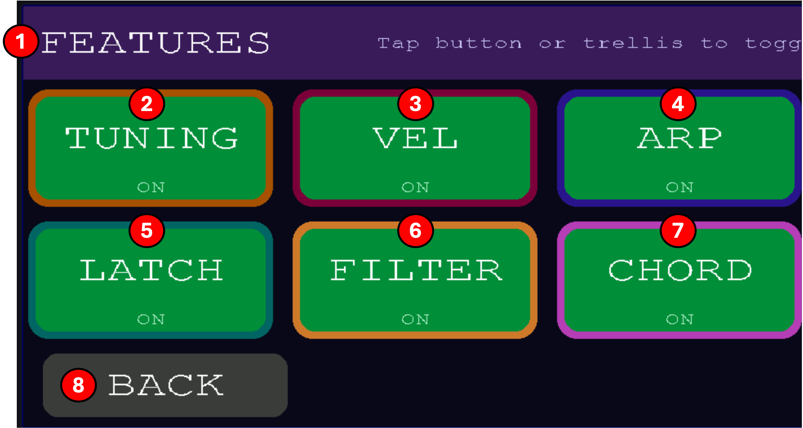

Screen elements
(1) Header
Titled FEATURES with a hint that features can be toggled from the touchscreen or from the front-panel buttons.
(2) TUNING
Enables the per-port microtonal Tuning editor across all presets.
(3) VEL
Enables the per-port Velocity curve editor across all presets.
(4) ARP
Enables the per-port Arpeggiator editor across all presets.
(5) LATCH
Enables the latch functionality that is set on the preset screen. If this functionality is enabled, the pressed notes on the master keyboard continue sounding after release until cleared if specified to do so in the mode select in the preset menu (Alat or Zlat)
(6) FILTER
Enables the per-port MIDI Filter editor across all presets.
(7) CHORD
Enables the per-port Chord Generator editor across all presets.
(8) BACK
Returns to the Config screen.

Notes
Note. Turning a feature off hides its editor tile in the preset menu (except latch) but preserves the per-preset settings underneath, turning it back on restores your previous configuration.

8.3 About Screen
The About screen shows identifying information about your unit. This is useful when contacting support or checking that you're on the latest firmware. Reach it via SYSTEM → ABOUT.
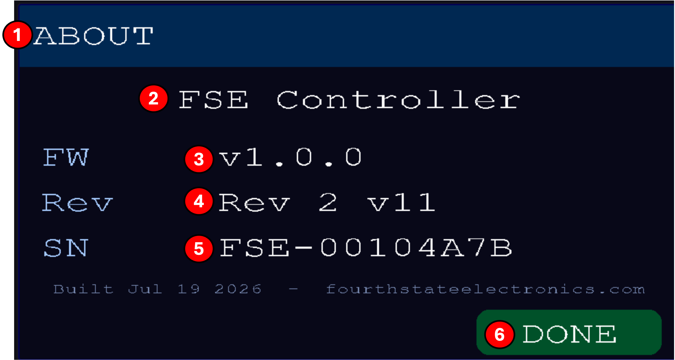

Screen elements
(1) Header
Titled ABOUT.
(2) Model name

(3) FW (firmware version)
The firmware version currently running on the unit.
(4) Rev (hardware revision)
The hardware board revision.
(5) SN (serial number)

(6) DONE
Returns to the Config screen.

9 Clock

The Clock screen configures the global tempo used by the arpeggiator, latching, and any downstream synth that syncs to MIDI clock. Reach it by tapping CLOCK on the Live screen.
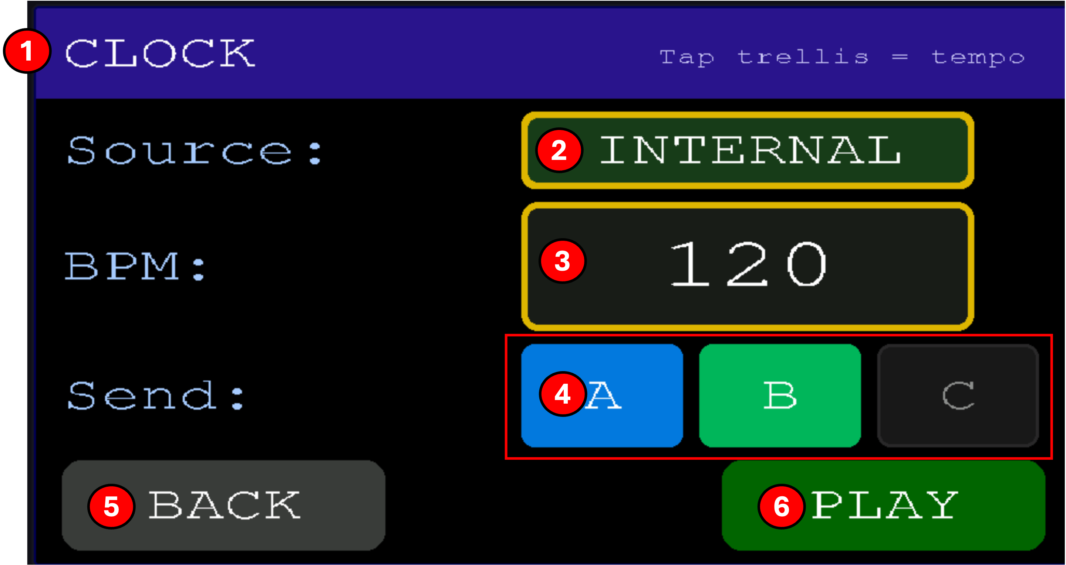

Screen elements
(1) Header + tap tempo hint
The banner shows CLOCK and a reminder that you can tap the buttons in time to set BPM.
(2) Source
Where clock ticks come from. INTERNAL uses the built-in tempo. EXTERNAL slaves to MIDI clock arriving on the MIDI IN port.
(3) BPM
The internal tempo, in beats per minute. Edit with Knob 1 or by tapping. Ignored when Source is EXTERNAL.
(4) Send port toggles (A, B, C)
Which output ports transmit MIDI clock. Tap to toggle each port. Highlighted ports are transmitting.
(5) BACK
Returns to the Live screen. Clock changes are applied immediately as you make them.
(6) PLAY
Starts/stops MIDI transport (Start/Stop messages) on the selected send ports.

Notes
Note. Clock is a global setting, it applies to every preset. Only which features consume the clock (arp, latch timing) are per-preset.

Tap tempo
On the Clock screen when Source is Internal, the buttons become a tap surface and glow purple. Tap steadily at your target tempo, 2 taps set the BPM to the interval, 3–4 taps stabilize to the rolling average. Pause more than 2 seconds to start fresh. Taps outside 60–240 BPM are ignored.

10 Panic

If notes get stuck, a synth misses a note-off, a sustain CC hangs, a latched chord won't release, you can always recover without touching the display.
Hold buttons 1 and 16 (top-left and bottom-right corners) together for half a second. The buttons flash red briefly, then:
- All Notes Off (CC 123) is sent on all 16 channels of all 3 ports
- Reset All Controllers (CC 121) sweeps every channel
- Sustain (CC 64 = 0) explicitly clears every channel
- Explicit note-off 0–127 is sent on each port's active channel
- Any latched chord is cleared
- Any playing arp is silenced
- MIDI clock transport (if internal) is stopped so downstream sequencers reset cleanly
Note. Panic works from any screen. The visual state doesn't change, panic silences the audio without disturbing your workflow.

11 Troubleshooting

The SD card shows as missing at boot
The card was slow to enumerate on power-up. The firmware retries mount up to three times before giving up. If it still fails: reseat the card; reformat to FAT32 on a computer and copy your BANK*.TTY files back.

A bank won't load
The Config screen briefly shows one of these messages:
- No SD card, the card is genuinely absent or the socket has failed.
- SD error, a transient failure; try again.
- Load failed, the file failed twice.
- Bad file size, the file is from a firmware version outside the auto-migrate path, or is corrupted.

Notes hang after switching presets
Should not happen, every preset switch sends note-offs before the new preset's PCs. If you see it, hit the panic combo (buttons 1 and 16) and please report the reproduction steps via the support URL.

A knob doesn't do anything after switching presets
This is the knob-pickup feature working correctly. Sweep the knob through the current internal value (visible on the Live screen) and it will start sending again.

The arp keeps playing after I released the chord
The port's arp is in Latch mode. Tap the currently-active preset button to stop it, or turn Latch off for that port in the Arp editor.

I want to reset one preset without affecting the others
The RESET button on Config resets the entire bank (all 16 presets). To reset a single preset, load a fresh bank slot into the preset, or manually re-edit its PROGRAM, COLOR, and NAME back to defaults.

Firmware update
Connect the FSE to your computer using the micro-USB port. Then open Softload, either the standalone app from https://www.fourthstateelectronics.com/downloads/ or the web version at https://www.fourthstateelectronics.com/softload/. Download the latest firmware .hex from the same downloads page, click Upload Firmware in Softload, and select the file. The FSE reboots into the new firmware when the flash completes.https://www.fourthstateelectronics.com/downloads/https://www.fourthstateelectronics.com/softload/

If Softload can't see the FSE
- Use Chrome or Edge. Web Serial isn't available in Safari or Firefox.
- Try a different USB cable. Some cables are power-only and can't carry data.
- Close any program that might be holding the serial port open, like Arduino IDE or another serial monitor.

12 Softload

Softload is the companion computer app for the FSE 1. It runs in your web browser, connects to the FSE over USB, and gives you a large-screen editor for banks and presets plus a one-click firmware updater. With the exception of firmware updates, everything softload does is also available on the FSE itself; softload just makes bulk editing, backups, and firmware updates much faster than doing it on the touchscreen.
Note. Softload requires Chrome or Edge, Web Serial and File System Access aren't available in Safari or Firefox. It works fully offline; no install and no internet connection are needed once the page has loaded.

Getting Softload
There are two ways to run softload:
- Web version, open fourthstateelectronics.com/softload in Chrome or Edge. Nothing to install. This is the simplest option and always gives you the latest release.
- Standalone binary, download the version for your platform (macOS Apple Silicon, macOS Intel, or Windows) from fourthstateelectronics.com/softload. Double-click to launch. The binary starts a tiny local web server, opens your browser to it, and shuts down when you close it.
Both versions are functionally identical.
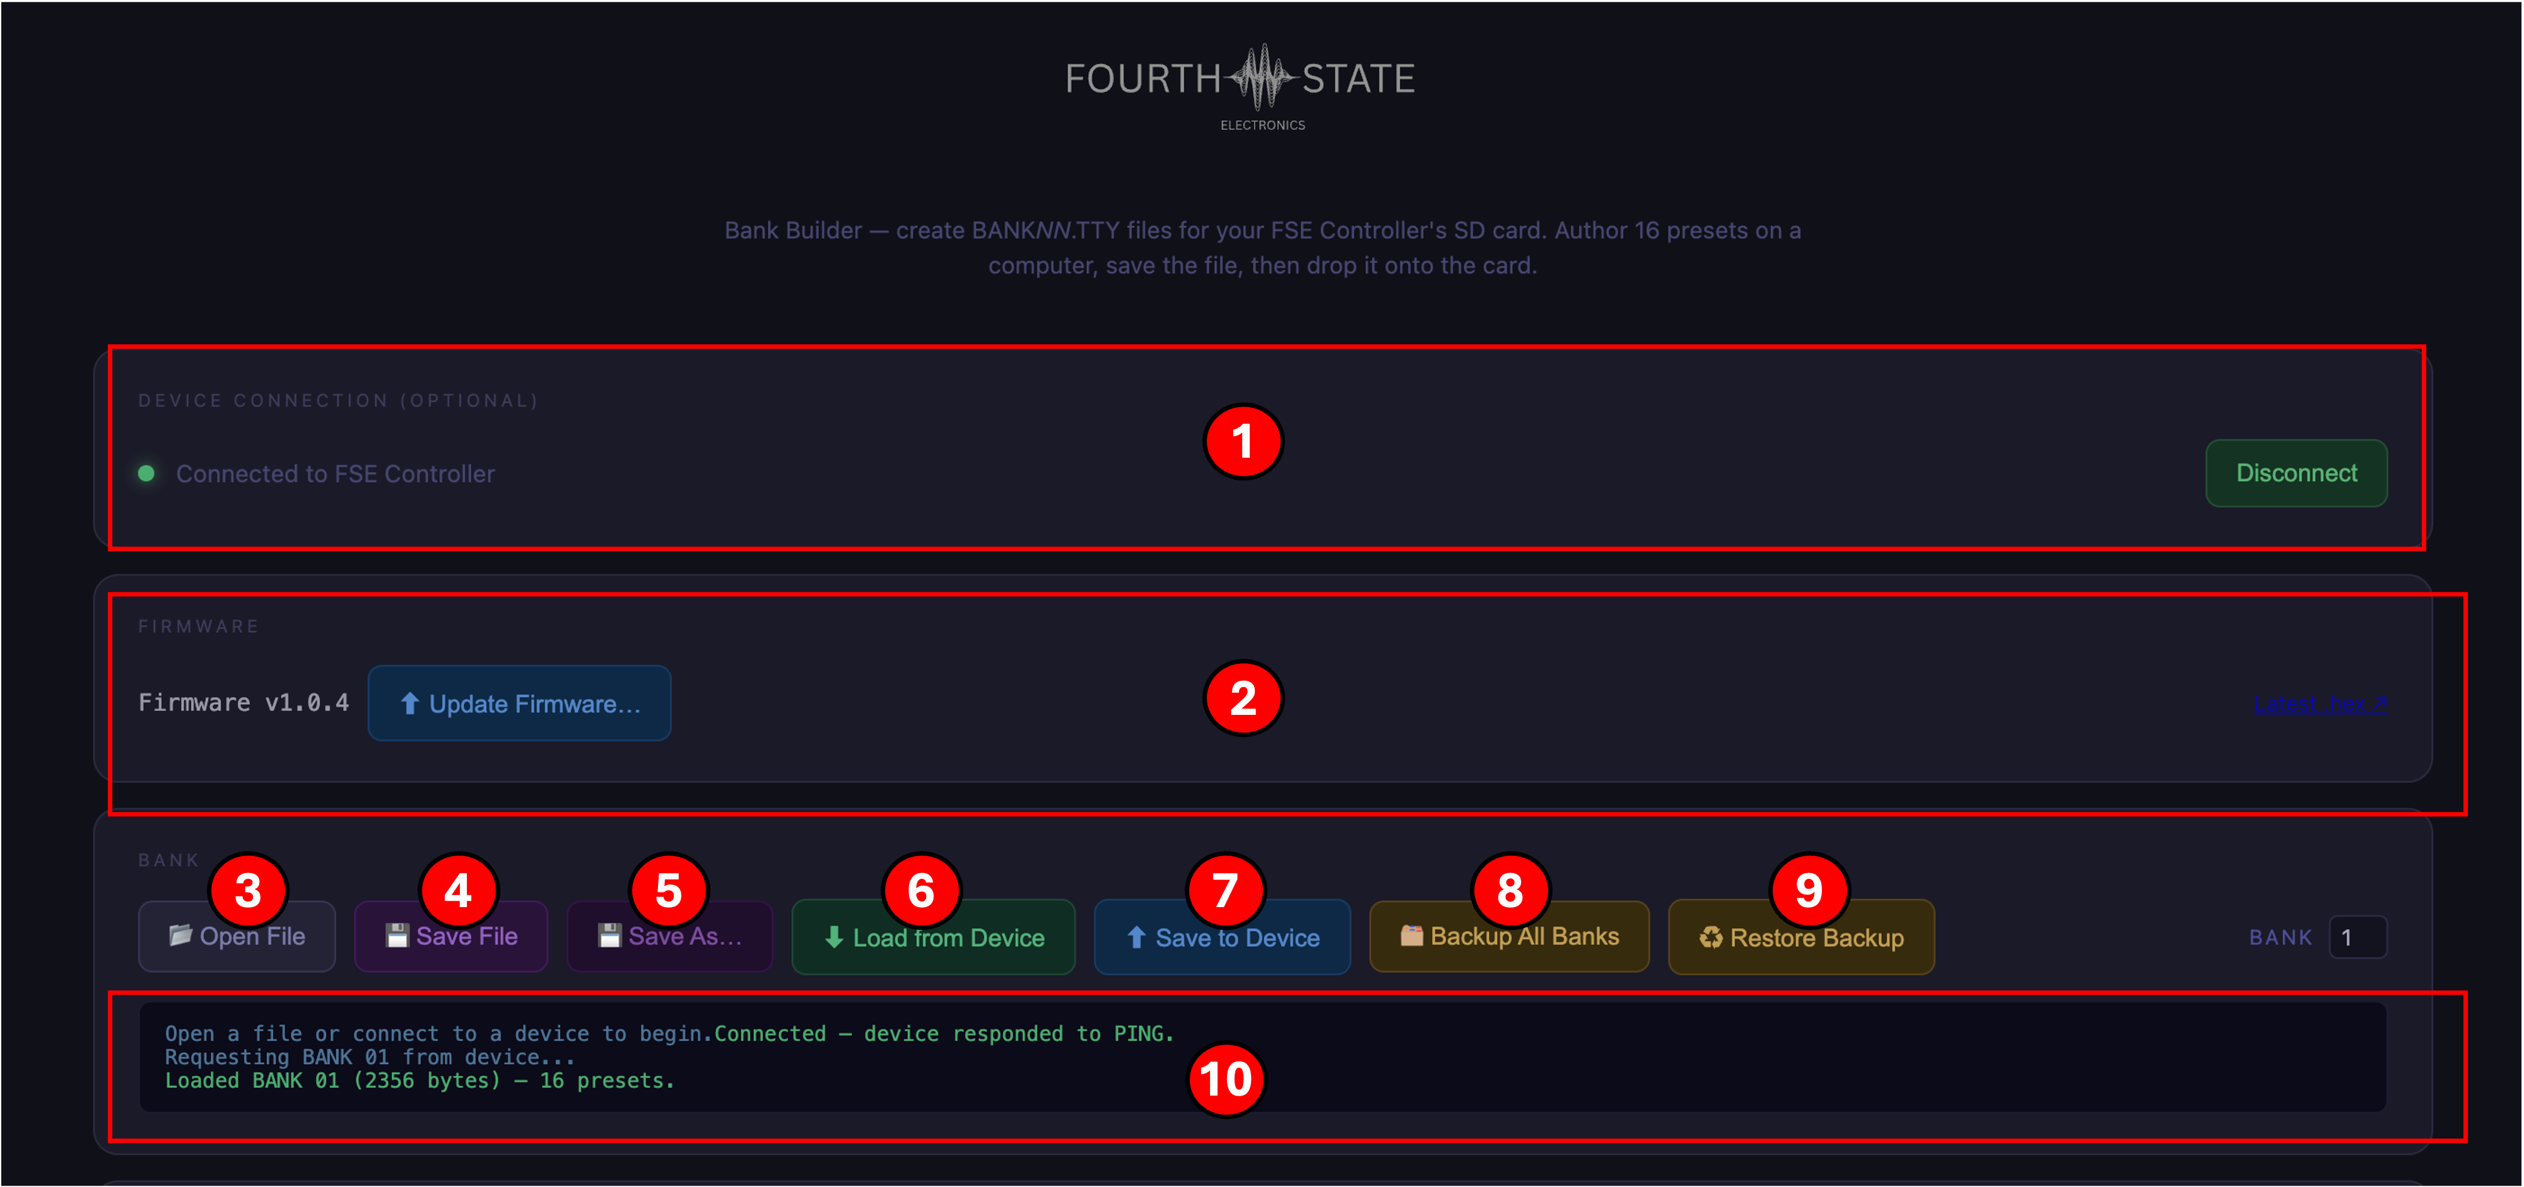

The Softload Window
The top half of the softload page groups tasks into three cards, in the order you'll use them: Device Connection, Firmware, and Bank. Below those is the Preset Editor for whichever bank you have loaded.
(1) Device Connection
Click Connect to Device. Chrome pops a serial-port picker; pick the FSE 1. If successfully connected, softload shows a green status dot, and unlocks every other card. Softload bank creation can also works with no device connected. Open File / Save File let you edit .tty bank files offline.
(2) Firmware
Shows the version currently running on your FSE (auto-queried on connect). Click Update Firmware and pick a .hex file to flash a new firmware over USB. An amber "UPDATING FIRMWARE" banner appears while the transfer runs; the FSE reboots automatically when done and softload reconnects. The Latest .hex link opens fourthstateelectronics.com/firmware in a new tab.
(3) New Bank
Start a fresh empty bank in the editor without needing a device connection or an existing file. All sixteen preset slots seed with default values, identical to what an empty SD slot on a fresh card would load. Pair with Save As... to write the bank to disk, or Save to Device to write it to the FSE's SD card.
(4) Open File
Load a .tty bank file from disk into the softload editor. Use this to work on an existing bank you previously downloaded or backed up.
(5) Save File
Write the currently-edited bank back to the same .tty file it was opened from. Disabled until you've either opened a file or done a Save As.
(6) Save As…
Write the currently-edited bank to a new .tty file. Use this to make a copy under a new name or save a bank you loaded from the device.
(7) Load from Device
Copy the numbered bank (see the BANK field on the right) from the FSE's SD card into the softload editor. Legacy banks from older firmware versions are auto-migrated on the first load.
(8) Save to Device
Write the bank currently open in the editor back to the FSE's SD card, overwriting the numbered bank slot. The FSE picks up the change immediately, no reboot needed.
(9) Backup All Banks
Pick a destination folder; softload downloads all sixteen banks from the FSE and writes them as BANK_01.tty … BANK_16.tty into a dated folder (e.g. "FSE Backup 2026-07-24"). Your rescue for accidental overwrites, do this before major edits.
(10) Restore Backup
Pick a previously-created backup folder; softload uploads any BANK_NN.tty files it finds to the matching slots on the FSE. Missing banks in the folder are left alone.
(11) Activity Log
A running record of every action softload takes, connect, load, save, backup, restore. If something fails, this is where the error message shows up (e.g. ERR:CHECKSUM, ERR:BADSIZE). Includes per-bank success / failure detail during Backup All Banks.
Note. If your FSE isn't idle when you click Update Firmware, softload shows an error such as ERR:BUSY_CLOCK. Stop the clock (CLOCK screen → STOP) and try again. If the update fails partway through, the FSE stays on the previous firmware, nothing is lost.
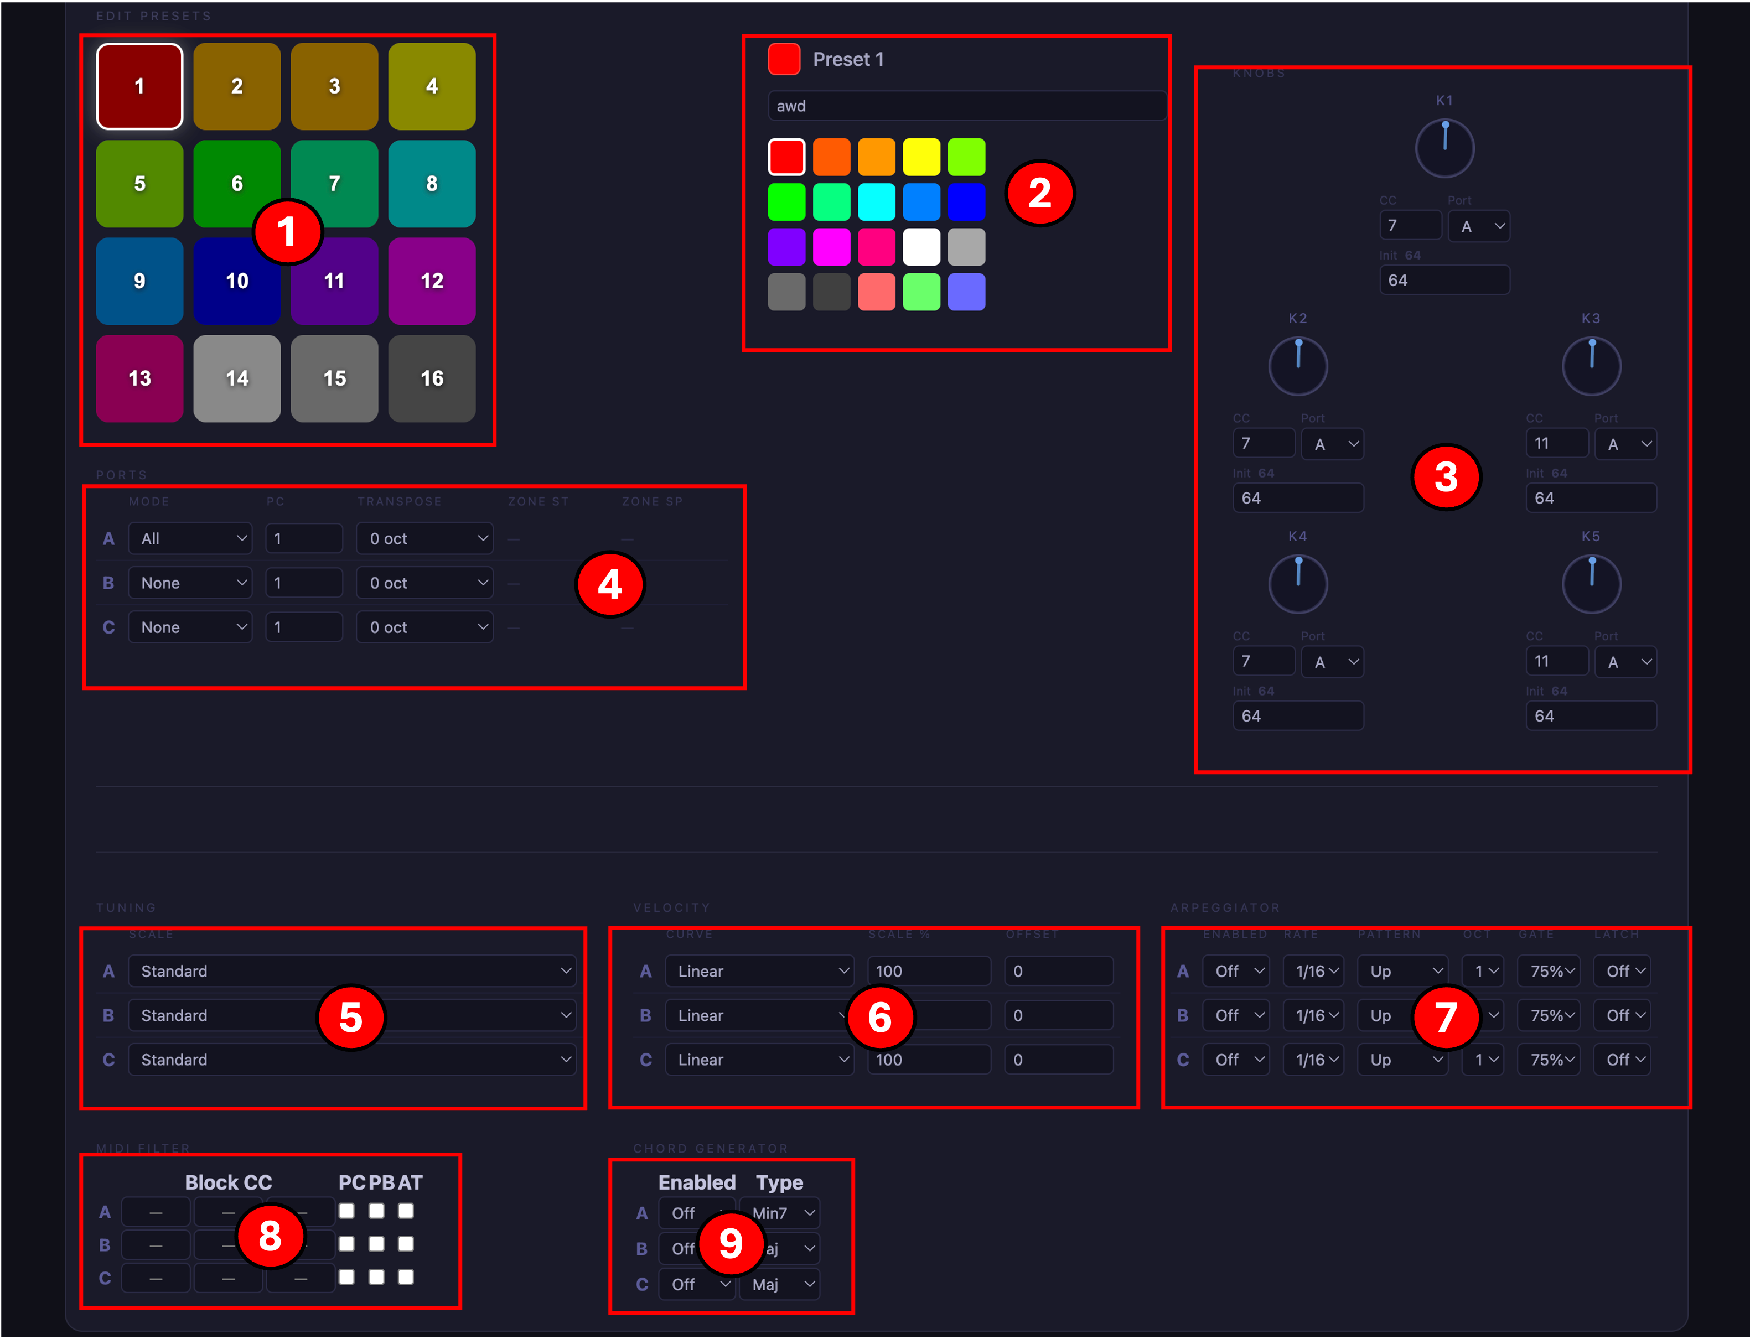

The Preset Editor
Once a bank is loaded, the Preset Editor at the bottom of the page is populated. Every setting the FSE exposes on-device is editable here, plus a few things much easier with a real keyboard and mouse (naming, color picking, bulk CC assignments).
Edits are held in softload's memory as you make them. Nothing is written back to the FSE until you click Save to Device (or Save File to save to disk).
(1) Preset selector
The sixteen buttons on the left mirror the physical buttons on the FSE. Each is colored with the preset's assigned color. The currently-selected preset is outlined in white. Click any button to switch to editing that preset, every field on the right updates to show that preset's data.
(2) Name and Color
Type up to 21 characters for the preset name in the text field. Below it, a 20-swatch palette; click any swatch to change the preset's pad color. Both the palette highlight and the preset selector button at left update instantly.
(3) Knobs
The five assignable knobs (K1–K5). For each knob, set the CC number it transmits, the output port (A, B, or C), and the startup value it sends when the preset loads. A live dial reflects the startup value.
(4) Ports
How each of the three output ports handles notes for this preset. Mode picks None / All / Zone / All Latch / Zone Latch. PC is the Program Change number transmitted on preset load. Transpose shifts every note by ±2 octaves. Zone Start / Zone Sp only appear when the mode is Zone or Zone Latch.
(5) Tuning
Per-port microtonal scale. Standard is 12-TET (no re-tuning). Other options include various EDOs, historical temperaments, and world scales like Slendro and Pelog. See Appendix A for the full list.
(6) Velocity
Per-port velocity shaping. Curve chooses the response shape (Linear, Soft, Hard, S-Curve, Fixed). Scale % scales the result 0–200%; Offset adds ±64 after the scale. See Appendix C for the curve reference.
(7) Arpeggiator
Per-port arpeggiator. Enabled turns it on. Rate is the note value (1/4 through 1/32). Pattern picks Up / Down / Up-Down / Random / As Played. Oct spans 1–4 octaves. Gate is the note length as a percent of the step. Latch keeps the arpeggiator running after you release the chord.
(8) MIDI Filter
Per-port MIDI event filter. Enter up to three CC numbers to block under Block CC (leave blank for unused). The PC / PB / AT checkboxes block Program Change / Pitch Bend / Aftertouch messages on that port. Useful for blocking sustain pedal to a synth that shouldn't receive it, for example.
(9) Chord Generator
Per-port chord expander. Enabled turns it on. Type picks the chord built above each played note, Maj, Min, Sus2, Sus4, Dim, Aug, Maj7, Min7, 7, Maj9, Min9, Add9. See Appendix B for the interval list.
Note. Softload's feature editors always show every field, even when the corresponding feature is disabled globally on the FSE. If a feature is off in SYSTEM → FEATURES on the device, softload will still let you edit its per-preset data, but the firmware silently ignores the settings until you turn the feature back on.

Saving your work
Nothing you do in the Preset Editor persists until you save. Two ways:
- Save to Device, writes the currently-edited bank back to the FSE's SD card, overwriting the numbered bank slot. The FSE picks up the change immediately.
- Save File / Save As, writes the bank to a .tty file on your disk. Good for making a backup before big edits or sharing banks with other FSE owners.
If you switch banks or close the browser tab without saving, your edits are lost.

13 Appendix

A Tuning Scales
Available on the Tuning editor per output port. Standard (12-TET) is the default, notes pass through unchanged. Non-standard tunings retune each note by combining note-on with a per-voice pitch-bend on the port's channel.
- Standard (12-EDO), Standard twelve-tone equal temperament. The default, no retuning applied.
- 19-EDO, Nineteen equal divisions of the octave. Improved minor thirds; closer to just intonation for many triads.
- 24-EDO, Quarter tones. Useful for Middle-Eastern and contemporary scales.
- 31-EDO, Thirty-one equal divisions. Very close approximation to quarter-comma meantone temperament.
- 5-limit Just Intonation, Chords built from small-integer frequency ratios. Pure thirds and fifths in the root key.
- Pythagorean, Fifth-based tuning. Perfect fifths at the expense of major thirds.
- Slendro, Traditional Indonesian five-note scale.
- Pelog, Traditional Indonesian seven-note scale.

B Chord Types
Available on the Chord Generator per output port. Intervals are semitones added to the played root note.
- Maj, Major triad, 0, 4, 7
- Min, Minor triad, 0, 3, 7
- Sus2, Suspended second, 0, 2, 7
- Sus4, Suspended fourth, 0, 5, 7
- Dim, Diminished, 0, 3, 6
- Aug, Augmented, 0, 4, 8
- Maj7, Major seventh, 0, 4, 7, 11
- Min7, Minor seventh, 0, 3, 7, 10
- 7, Dominant seventh, 0, 4, 7, 10
- Maj9, Major ninth, 0, 4, 7, 11, 14
- Min9, Minor ninth, 0, 3, 7, 10, 14
- Add9, Add nine, 0, 4, 7, 14

C Velocity Curves
Available on the Velocity editor per output port. The curve shapes the response of the incoming velocity before gain and offset are applied.
- Lin (Linear), No change, velocity passes through unmodified.
- Soft, Flatter response. Harder to reach top velocities; smooths an over-sensitive keyboard.
- Hard, Steeper response. Softer touches produce louder notes; useful for cutting through a mix.
- S-Cv (S-Curve), Expressive middle range with compressed extremes, good default for keys players.
- Fix (Fixed), Every note is transmitted at velocity 64 regardless of input.

14 Specifications

Preliminary specifications. Values marked TBD are placeholders, replace with final figures before printing.

Physical
- Dimensions (L × W × H), 5.9 × 4.5 × 2.3 in (not including feet)
- Weight, 1 lb
- Chassis, anodized aluminum

Power
- Input, USB-C, 5 V DC
- Current draw (typical), TBD mA
- Current draw (peak), TBD mA
- Power consumption, TBD W

MIDI
- Outputs, 3 × 5-pin DIN (A, B, C)
- Inputs, 1 × 5-pin DIN
- Clock, 24 PPQ, sends / receives Start-Stop
- Latency (in → out), TBD ms typical

USB
- Rear USB-C, 5 V power only
- Side micro-USB, Firmware update, softload, backup / restore
- Data speed, USB 2.0 High-Speed (480 Mbps)

Storage
- Card slot, microSD
- Filesystem, FAT32
- Tested capacity, 4 GB
- Banks per card, 16
- Presets per bank, 16

Controls & Display
- Knobs, 5 × 12 mm potentiometers
- Buttons, 16 × RGB backlit silicone buttons
- Display, 1.9″ IPS TFT, 320 × 172, capacitive multi-touch
- Power switch, Rocker (rear)

15 Support

If you get stuck, you'll find help through one of the channels below. For any support request, please include your firmware version and serial number, both are shown on the ABOUT screen (SYSTEM → ABOUT).

Getting Help
- Email, support@fourthstateelectronics.com. Typical response within two business days.
- Website, fourthstateelectronics.com, knowledge base, tutorials, video walkthroughs, and the online version of this manual.

Firmware Updates
New firmware ships regularly, adding features and fixing bugs. Update at any time using the following steps:
- Download the latest .hex from fourthstateelectronics.com/downloads/.
- Connect the FSE to your computer using the side micro-USB port. Open Softload, either the standalone app from the same downloads page or the web version at fourthstateelectronics.com/softload/.
- In Softload, click Upload Firmware and select the .hex file. The FSE reboots into the new firmware when the flash completes.
- On next boot, check ABOUT to confirm the new firmware version.
Note. Your saved banks and settings survive firmware updates. Automatic migration handles bank files written by older firmware versions.

Softload
Bulk preset editing on a computer is done in Softload, our browser-based companion app. No install required: connect the side micro-USB port, open fourthstateelectronics.com/softload/ in Chrome or Edge, and click Connect. Edit every preset field (routing, tuning, chord generator, velocity, arpeggiator, MIDI filter), back up your whole bank set to a .tty file, and restore from a backup. A standalone desktop version is available on the downloads page for offline use.

Warranty
The Fourth State FSE 1 is covered by a one-year limited warranty from the date of original purchase, covering defects in materials and workmanship. Coverage extends to the original purchaser and is not transferable.
Not covered: physical damage, liquid damage, modifications outside firmware updates, and normal cosmetic wear.
If your unit is defective within the warranty period, email support@fourthstateelectronics.com with your serial number, order number, and a description of the fault. We'll repair or replace the unit at our option; if neither is practical, we'll issue a full refund. Shipping costs for warranty returns are covered by Fourth State Electronics within the continental United States; international customers are responsible for return shipping.
Fourth State Electronics
Designed and assembled in the USA
© Fourth State Electronics. All rights reserved.

