FOURTH STATE ELECTRONICS
fourthstateelectronics.com
support@fourthstateelectronics.com
Full manual online
fourthstateelectronics.com/manual
Batch 1 · Unit #_____

FSE
CONTROLLER
Quick Start Guide
— — —

QUICK START
1. Plug in power. Connect any USB-C cable + 5 V USB power source to the POWER port on the back.
2. Turn the unit on. Flip the rocker switch on the back to ON.
3. Connect your master keyboard. Plug a 5-pin MIDI cable from your keyboard's MIDI OUT into the MIDI IN jack on the side of the FSE.
4. Connect your destination synths. Plug MIDI cables from MIDI OUT A / B / C on the back into the MIDI IN of each synth or effect.
5. Turn Local Control OFF on your master keyboard (if it has onboard sounds).
6. Set MIDI channels. On the Live screen, tap SYSTEM (bottom-left). Set the base MIDI channel for A, B, and C to match your synths (typically 1, 2, 3).
7. Play through Preset 1 to verify. Preset 1 sends every note through Port A. Knobs K1–K5 send CC 7 (volume) by default.

8. Switch presets. Tap any of the 16 pad buttons to load that preset.
9. Edit on-device. From Live, tap PRESET on the touch screen (center-bottom) to open the editor for the current pad, or KNOBS (right-bottom) for knob assignments. Edit features from the features tab in the system screen
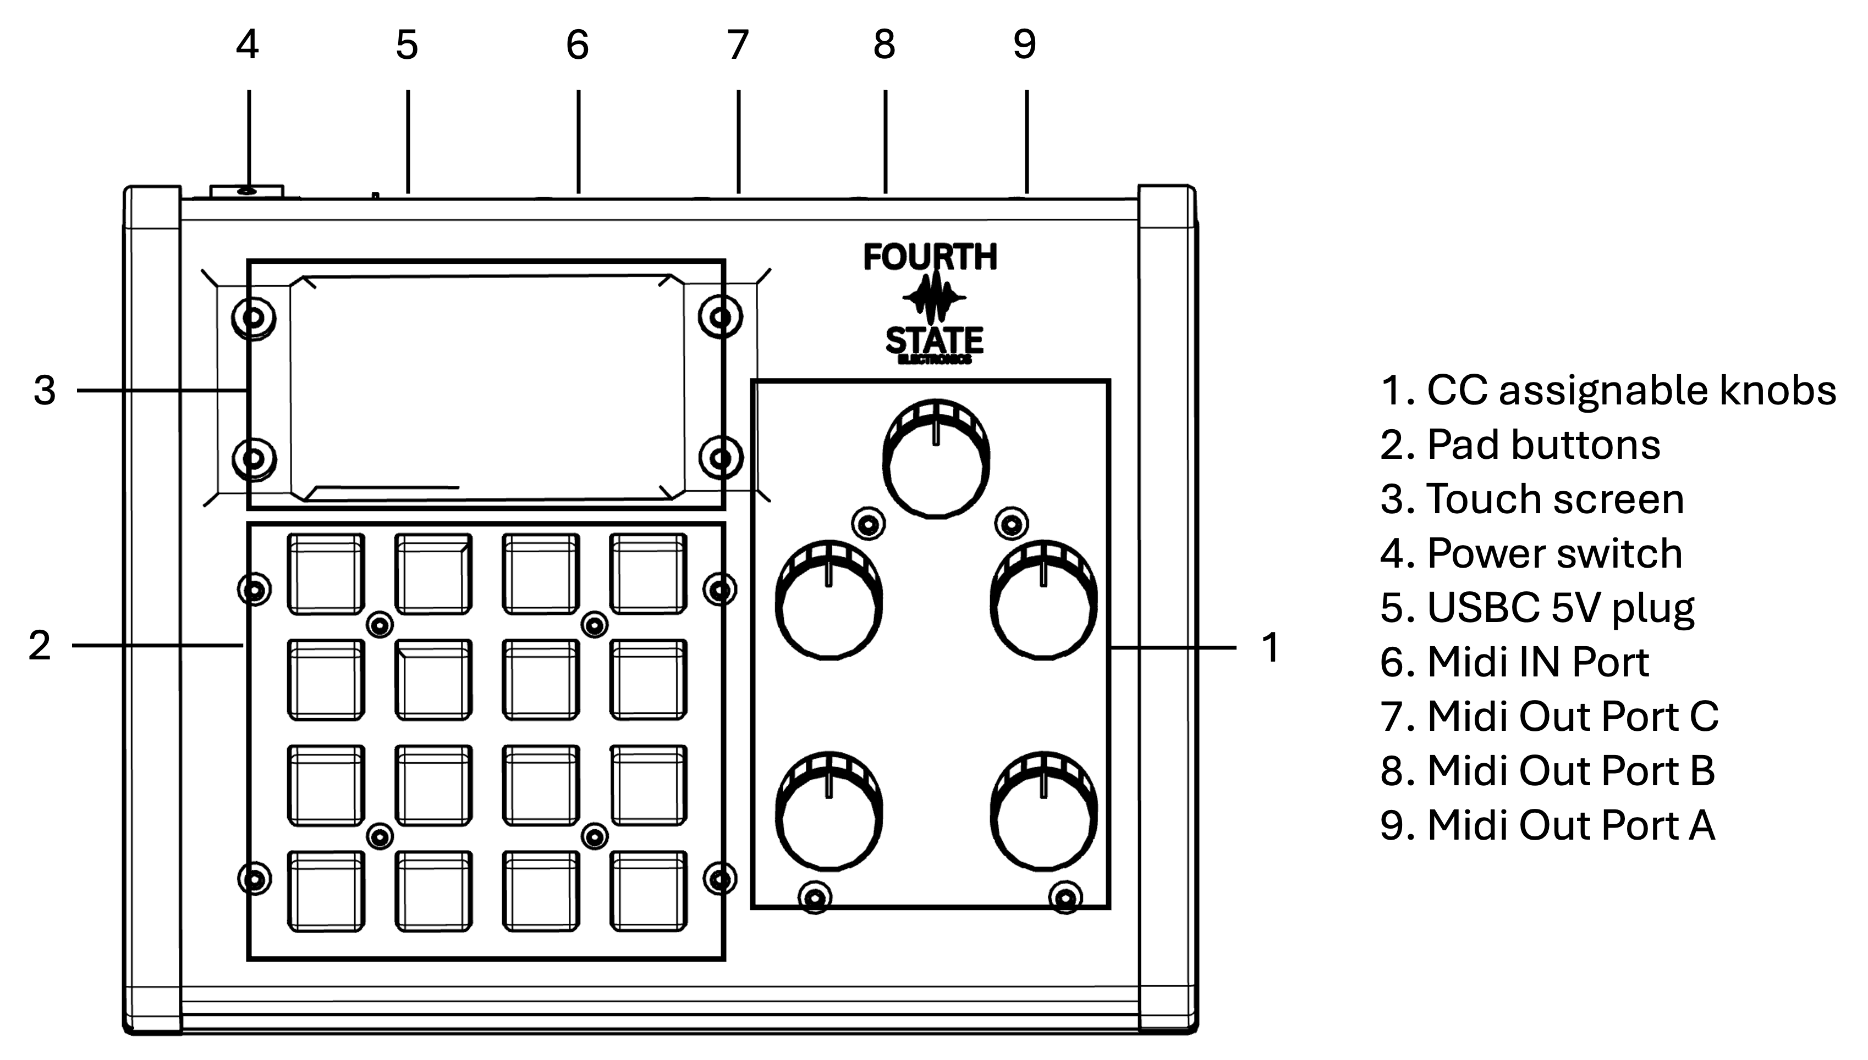
You're up and playing. See the full manual online for editing details.

